**WPA – Artistic Pool Division**

**2015**

# Official Shot / Challenge Program

# Shot Program and Selection

1. For each degree of difficulty (DOD; point value) in each discipline, players will select one shot (a, b, or, c). Therefore, players will select 5 shots in each discipline and shoot a total of 40 shots.
2. Players are locked into the selection once they take a legitimate stroke at the shot. Warm up strokes and accidentally nudging a ball with the cue tip do not constitute a legitimate stroke.
3. Players will receive three attempts to make each shot. Players may only make each shot once.
4. Scoring: players will receive the full DOD value if the shot is made on the first attempt, the DOD value minus one if the shot is made on the second attempt, the DOD value minus two if the shot is made on the third attempt, or zero if the shot is not made on any attempt. Exception: Shots with special scoring, as outlined in the shot program. (Discipline 2 – Shot 4; see scoresheet)

# Tournament Format

1. Players will be divided into ‘flights’ of 2, 3, or 4 players, depending on the number of total entrants and tables available. Flights will be determined at the players meeting or earlier. Players will be divided into groups based on ranking and flights will consist of a random selection of a player from each group.
2. Each flight will play four rounds. Each round will consist of two shot disciplines grouped as follows: 1 and 2, 3 and 4, 5 and 6, and 7 and 8. The order of the grouped disciplines is at the discretion of the tournament director.
3. Before each round, players will receive a set number of minutes for practice time on the tournament table. The amount of time will be decided at the players meeting or earlier. Typical practice time is four minutes.
4. Playing order will consist of a ‘rotating lead off’ process. See ‘Play Order’ below.

# Standings and Tiebreakers

1. Player’s total point score after shooting 40 shots will determine the final standings.
2. Discipline champions will be determined based on player’s total points in a given discipline.
3. If player’s are tied on point value for either overall ranking or discipline champion, the following tiebreakers will be used:
   1. 1st attempt makes
   2. 2nd attempt makes
   3. 3rd attempt makes
   4. 1st attempt points
   5. 2nd attempt points
   6. 3rd attempt points
4. If players remain tied for discipline champion, the following process will be used:
   1. Players will lag to start. The winner of the lag will decide in which position they want to shoot.
      1. If 3 or more players are tied, lag pairings will be determined by coin flips or “rock, paper, scissors”.
   2. Players will receive no warm-ups.
   3. Players will shoot each 6 point shot in the discipline, taking 1 attempt per shot.
   4. The player with the most makes wins the discipline. If multiple players tie for the most makes, any other player who did not tie at this point is eliminated.
   5. Players will shoot all three shots in succession. Players will not alternate between attempts.
   6. If players are still tied, players will move on to the 7 point shots and so on.
   7. Play will rotate between rounds. The player that shoots 1st for the 6 point shots will not shoot 1st for the 7 point shots.

# Play Order – 2 player flight

|  |  |
| --- | --- |
| Player A | Player B |

|  |  |  |  |  |  |  |  |
| --- | --- | --- | --- | --- | --- | --- | --- |
| **Disc. 1 - Trick/Fancy** | | **Disc. 2 - Special Arts** | | **Disc. 3 - Draw** | | **Disc. 4 - Follow** | |
| **1** | **A B** | **1** | **B A** | **1** | **A B** | **1** | **B A** |
| **2** | **B A** | **2** | **A B** | **2** | **B A** | **2** | **A B** |
| **3** | **A B** | **3** | **B A** | **3** | **A B** | **3** | **B A** |
| **4** | **B A** | **4** | **A B** | **4** | **B A** | **4** | **A B** |
| **5** | **A B** | **5** | **B A** | **5** | **A B** | **5** | **B A** |

|  |  |  |  |  |  |  |  |
| --- | --- | --- | --- | --- | --- | --- | --- |
| **Disc. 5 – Bank/Kick** | | **Disc. 6 – Stroke** | | **Disc. 7 – Jump** | | **Disc. 8 – Masse** | |
| **1** | **A B** | **1** | **B A** | **1** | **A B** | **1** | **B A** |
| **2** | **B A** | **2** | **A B** | **2** | **B A** | **2** | **A B** |
| **3** | **A B** | **3** | **B A** | **3** | **A B** | **3** | **B A** |
| **4** | **B A** | **4** | **A B** | **4** | **B A** | **4** | **A B** |
| **5** | **A B** | **5** | **B A** | **5** | **A B** | **5** | **B A** |

# Play Order – 3 player flight

|  |  |  |
| --- | --- | --- |
| Player A | Player B | Player C |

|  |  |  |  |  |  |  |  |
| --- | --- | --- | --- | --- | --- | --- | --- |
| **Disc. 1 - Trick/Fancy** | | **Disc. 2 - Special Arts** | | **Disc. 3 - Draw** | | **Disc. 4 - Follow** | |
| **1** | **A B C** | **1** | **C A B** | **1** | **B C A** | **1** | **A B C** |
| **2** | **B C A** | **2** | **A B C** | **2** | **C A B** | **2** | **B C A** |
| **3** | **C A B** | **3** | **B C A** | **3** | **A B C** | **3** | **C A B** |
| **4** | **A B C** | **4** | **C A B** | **4** | **B C A** | **4** | **A B C** |
| **5** | **B C A** | **5** | **A B C** | **5** | **C A B** | **5** | **B C A** |

|  |  |  |  |  |  |  |  |
| --- | --- | --- | --- | --- | --- | --- | --- |
| **Disc. 5 – Bank/Kick** | | **Disc. 6 – Stroke** | | **Disc. 7 – Jump** | | **Disc. 8 – Masse** | |
| **1** | **C A B** | **1** | **B C A** | **1** | **A B C** | **1** | **B C A** |
| **2** | **A B C** | **2** | **C A B** | **2** | **B C A** | **2** | **C A B** |
| **3** | **B C A** | **3** | **A B C** | **3** | **C A B** | **3** | **A B C** |
| **4** | **C A B** | **4** | **B C A** | **4** | **A B C** | **4** | **B C A** |
| **5** | **A B C** | **5** | **C A B** | **5** | **B C A** | **5** | **C A B** |

# Play Order – 4 player flight

|  |  |  |  |
| --- | --- | --- | --- |
| Player A | Player B | Player C | Player D |

|  |  |  |  |  |  |  |  |
| --- | --- | --- | --- | --- | --- | --- | --- |
| **Disc. 1 - Trick/Fancy** | | **Disc. 2 - Special Arts** | | **Disc. 3 - Draw** | | **Disc. 4 - Follow** | |
| **1** | **A B C D** | **1** | **B C D A** | **1** | **C D A B** | **1** | **D A B C** |
| **2** | **B C D A** | **2** | **C D A B** | **2** | **D A B C** | **2** | **A B C D** |
| **3** | **C D A B** | **3** | **D A B C** | **3** | **A B C D** | **3** | **B C D A** |
| **4** | **D A B C** | **4** | **A B C D** | **4** | **B C D A** | **4** | **C D A B** |
| **5** | **A B C D** | **5** | **B C D A** | **5** | **C D A B** | **5** | **D A B C** |

|  |  |  |  |  |  |  |  |
| --- | --- | --- | --- | --- | --- | --- | --- |
| **Disc. 5 – Bank/Kick** | | **Disc. 6 – Stroke** | | **Disc. 7 – Jump** | | **Disc. 8 – Masse** | |
| **1** | **A B C D** | **1** | **B C D A** | **1** | **C D A B** | **1** | **D A B C** |
| **2** | **B C D A** | **2** | **C D A B** | **2** | **D A B C** | **2** | **A B C D** |
| **3** | **C D A B** | **3** | **D A B C** | **3** | **A B C D** | **3** | **B C D A** |
| **4** | **D A B C** | **4** | **A B C D** | **4** | **B C D A** | **4** | **C D A B** |
| **5** | **A B C D** | **5** | **B C D A** | **5** | **C D A B** | **5** | **D A B C** |



# Revisions From Previous Version (Revision 2015A)

Corrected “Play Order – 3 player flight”

Re-formatted Rules of Artistic Pool

Removed rule requiring props to come from the venue’s inventory

Discipline 2 – 2c: Removed “regular” cue requirement

Discipline 2 – 3a: Added Special Note in case table won’t accept the # of balls

Discipline 2 – 5c: Added Special Note in case table won’t accept the # of balls

Discipline 5 – 5c: Removed “short” cue requirement

Discipline 6 – 4a: Corrected misspelling “Discipline”

Discipline 6 – 4a: Corrected entire description

Discipline 7 – 3a: Added Special Note for masse cloth requirement

Discipline 8 – 5c: Corrected rail #’s in description

# Rules of Artistic Pool

## *General Rules*

1. The player is responsible for knowing the setup and requirements set forth in the shot program. All questions should be resolved prior to the match with the tournament director.
2. All shots will be judged based on the intent of the shot.  If any loophole is found that changes the intent of the shot, those changes to the shot will not be allowed.
3. A full, intentional stroke counts as an attempt. Accidentally nudging the cue ball does not count as an attempt.
   1. *Exception 1*: Wing shots, once a ball is rolled, it counts as an attempt.
   2. *Exception 2*: Any shot requiring multiple hits. The first full, intentional stroke counts as an attempt. Subsequent cue contact with the cue ball or object balls count as a hit. For example, if the shot calls for the cue ball to be hit twice, nudging the cue ball on the second hit counts as a hit.
   3. On shots requiring multiple hits, after the initial hit, players may take as many strokes as necessary to complete subsequent hits. For example, if the shot calls for the cue ball to be hit twice, a player attempting the second hit but completely missing the cue ball may take another stroke to try to hit the cue ball as long as other parameters of the shot are met.
4. Table judge’s and tournament director’s decisions are final.

## *Ball and Prop Placement and Positioning*

1. Any balls or object specified as ‘ball-in-hand’ may be placed anywhere on the table, provided that the intent of the shot is preserved.
2. Any balls or object specified as ‘ball-in-hand’ but has additional positioning requirements may be adjusted freely by the player provided that the additional requirements are met.
3. All balls specified as ‘hanging near a pocket’ may be freely adjusted by the player near that pocket within reason.
4. Any object or ball that must be positioned within a zone must be completely in that zone.
5. Any ball that must come to rest within a zone will be considered in that zone if any part of the ball is within the zone, measured by the edge of the ball.
6. All chalk cubes placed on the table must be well up, and must be square with the table (may not be rotated), unless otherwise stated.
7. Chalk cubes may be positioned anywhere on the rail at the player’s discretion.
8. All measurements of 1 chalk’s width will be measured with a cube of chalk held at mid-ball height (the widest part of the ball), unless otherwise stated.

## *Shot Allowances and Restrictions*

1. It is always okay for a ball to contact an extra cushion near a ball hanging in a pocket, unless otherwise stated.
2. It is always okay for the cue ball to scratch, unless otherwise stated.
3. If there is a helper ball – hanging ball combination, it is always okay for the cue ball to contact either the helper ball or hanging ball directly. Rules 1 and 2 still apply.
4. Extra contact between balls is not allowed, unless otherwise specified.
5. At no time may any ball (cue ball or object ball) or prop fly off the table.
6. Players are free to shoot the mirror image of any shot.  Please note that rotating a shot 90 degrees is not the mirror image and will not be allowed.
7. Players are free to shoot any part of any shot with either hand.
8. Players may not switch cues during a shot unless otherwise specified or due to equipment failure. Players may switch cues between attempts.
9. Players must keep at least one foot on the floor when shooting. It is allowable for a player to “raise the floor” using any object.

## *Equipment*

1. All cues must be a minimum of 40 inches in length.
2. Players are allowed to place chalk or other objects underneath the bridge head, or bridge butt, as needed provided those other objects do not interfere with the shot.
3. All vertical masse shots and Discipline 7 – 3a will require the use of a masse cloth (extra piece of standard cloth) or the Stefano Pelinga Cloth Shield.
4. If a masse or break cloth is required for a shot, the player has the option of removing the extra cloth from the table during the course of the shot. If the player disturbs anything other than the cloth in this process, it will be a foul and count as a missed attempt.

**DISCIPLINE**

**1**

**TRICK & FANCY SHOTS**

# Discipline 1 – Shot 1a – 6 points

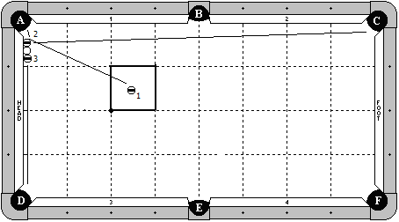

**Cue Ball**

Frozen to the head cushion and frozen to the 2 & 3 balls.

**Object Balls**

1 ball in hand within indicated zone. 2 ball frozen to the cushion and to the cue ball. 3 ball frozen to the cue ball, but does not need to be frozen to the cushion.

**Objective**

Shoot the 1 ball into the 2 ball. The 1 ball will go into pocket ‘A’. The 2 ball will bank into pocket ‘C’. The 3 ball will go into pocket ‘D’.

**Special Notes**

At the conclusion of the shot, the cue ball may not be more than 1 chalk’s width away from the head cushion.

# Discipline 1 – Shot 1b – 6 points

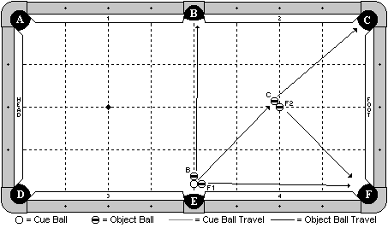

**Cue Ball**

In hand, within two ball widths of slate cut of pocket ‘E’.

**Object Balls**

‘B’ and ‘F1’ balls are in hand, frozen to the cue ball. ‘C’ and ‘F2’ balls are frozen with ‘F2’ ball on the foot spot and ‘C’ ball adjustable.

**Objective**

Shoot the cue ball towards ‘C’ ball. All 4 balls will go as diagrammed.

**Special Notes**

None.

# Discipline 1 – Shot 1c – 6 points

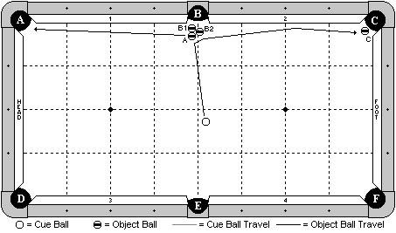

**Cue Ball**

In hand, behind the centerline of the table.

**Object Balls**

All object balls as diagrammed and adjustable.

**Objective**

Shoot the cue ball into ‘A’ ball. ‘A’ ball will go into pocket ‘A’. ‘B1’ will go into pocket ‘B’ by the combination with the ‘A’ ball. Cue ball will carom off and make ‘B2’ ball into pocket ‘B’. Cue ball will carom off and travel down the cushion to make ‘C’ ball.

**Special Notes**

None.

# Discipline 1 – Shot 2a – 7 points

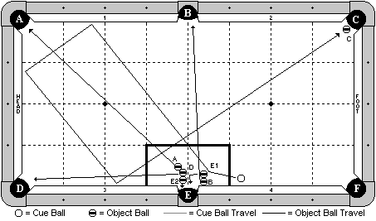

**Cue Ball**

In hand.

**Object Balls**

‘E1’ and ‘B’ balls are frozen, with ‘B’ ball also frozen to the cushion. ‘D’ ball is frozen to both ‘A’ and ‘E2’ balls. All 5 balls are adjustable within the box zone. ‘C’ ball is hanging near pocket ‘C’.

**Objective**

Shoot the cue ball to ‘E1’ ball. All 5 balls will go as pocket letter designates. The cue ball will travel 3 cushions to make ‘C’ ball.

**Special Notes**

None.

# Discipline 1 – Shot 2b – 7 points

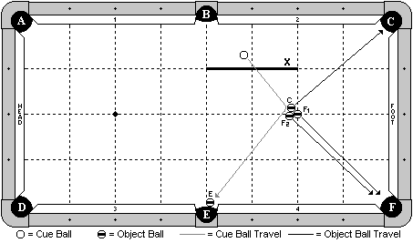

**Cue Ball**

In hand, behind line ‘X’.

**Object Balls**

A cluster of 3 balls is frozen as diagrammed, with ‘F1’ ball on the foot spot. ‘E’ ball is hanging near pocket ‘E’ and is adjustable.

**Objective**

Shoot the cue ball into ‘C’ ball. ‘C’ and ‘F1’ balls will go as diagrammed. The cue ball will carom off into ‘F2’ ball, making it in pocket ‘F’. The cue ball will carom off and make ‘E’ ball.

**Special Notes**

None.

# Discipline 1 – Shot 2c – 7 points

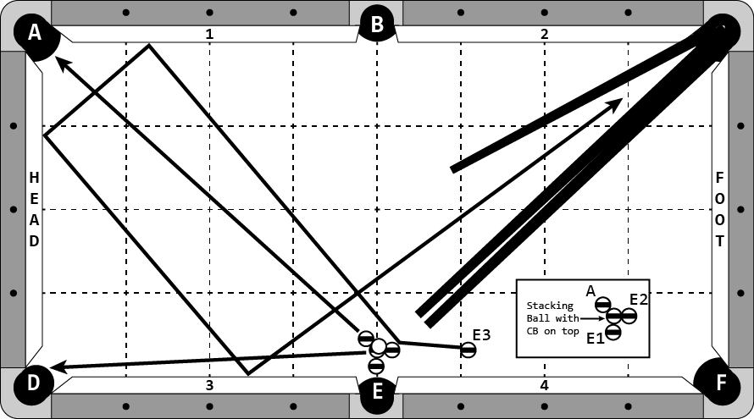

**Cue Ball**

On top of a stacking ball.

**Object Balls**

Four balls in a cluster as diagrammed in inset. The middle ball in the cluster is a stacking ball. ‘E3’ ball in hand behind the 3rd diamond. Two regular cue sticks and one short stick form the classic ‘railroad’ formation as diagrammed in pocket ‘C’.

**Objective**

Shoot ‘E3’ ball into ‘E2’ ball. Balls will go into pockets as designated by letters. The stacking ball will go in to pocket ‘D’. ‘E3’ ball will contact cushion 1, head cushion, cushion 3, travel between the cues, enter the ‘railroad’, go up the sticks, turn the corner, come down the two regular sticks, carom off of cue ball and go in pocket ‘E’.

**Special Notes**

‘E3’ ball must contact cue ball before going in pocket ‘E’.

A regular ball with a washer may be used in lieu of a stacking ball. If the washer interferes with the shot, whatever the result is will stand.

**During setup, players may not roll the cue ball on the cue sticks to test either the turn at the corner pocket or where the cue sticks are aimed. Doing so will count as an attempt.**

# Disicpline 1 – Shot 3a – 8 points

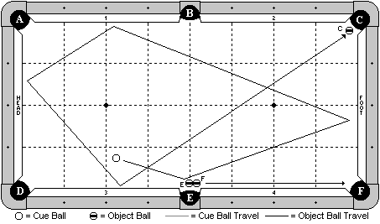

**Cue Ball**

In hand, at least one ball width from ‘E’ ball.

**Object Balls**

‘E’ and ‘F’ balls are as diagrammed and adjustable. ‘C’ ball is hanging near pocket ‘C’.

**Objective**

Shoot the cue ball and make ‘E’ ball in pocket ‘E’, and ‘F’ ball in pocket ‘F’. The cue ball will travel 4 cushions as diagrammed and make ‘C’ ball.

**Special Notes**

None.

# Discipline 1 – Shot 3b – 8 points

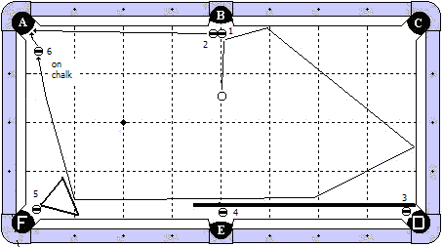

**Cue Ball**

In hand, behind the 1st diamond line from pocket ‘B’.

**Object Balls**

1 & 2 balls near pocket ‘B’. 3 ball near pocket ‘D’, frozen to the butt end of the cue stick. 4 ball near pocket ‘E’, frozen to the cue stick. 5 ball near pocket ‘F’ with a rack positioned as diagrammed. 6 ball in hand near pocket ‘A’, balanced on a piece of new chalk (well up).

**Objective**

Shoot the cue ball into the 1 ball. The 1 ball will go in pocket ‘B’ and the 2 ball will go in pocket ‘A’. The cue ball will travel the indicated path, hit the cue stick, causing the 3 and 4 balls to be made in their corresponding pockets. The cue ball will then hit the rack, making the 5 ball, and then hit the 6 ball, knock it off the chalk, and make it in pocket ‘A’.

**Special Notes**

The cue ball may hit the long cushion before hitting the rack. The 6 ball must be knocked off the chalk by the cue ball. Players selecting this shot will be required to provide the cue stick. If the cue ball jumps over the cue stick and is trapped between the cue stick and rail, the shot is no good.

# Discipline 1 – Shot 3c – 8 points

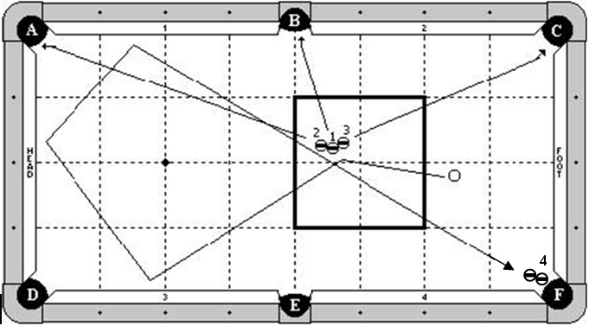

**Cue Ball**

In hand, behind the second diamond line.

**Object Balls**

Balls 1,2,3 are in hand as diagrammed within the indicated zone. Ball 4 combo is hanging near pocket ‘F’.

**Objective**

Shoot the cue ball into the 1 ball, causing the 3 balls to split as diagrammed and go into pockets A,B & C. The cue ball will travel 3 cushions as diagrammed and make the 4 ball in pocket F.

**Special Notes**

None.

# Discipline 1 – Shot 4a – 9 points

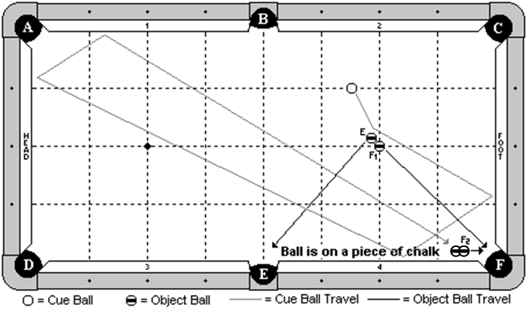

**Cue Ball**

In hand.

**Object Balls**

‘F1’ ball on foot spot. ‘E’ ball frozen to ‘F1’ ball and adjustable. An object ball is frozen to ‘F2’ object ball, ‘F2’ object ball is balanced on a piece of new chalk (well up). ‘F2’ ball is adjustable.

**Objective**

Shoot the cue ball into ‘E’ ball. ‘E’ ball will go in pocket ‘E’. ‘F1’ ball will go in pocket ‘F’. The cue ball will travel 4 cushions as diagrammed, hitting ‘F2’ ball combo making “F2” ball in pocket ‘F’.

**Special Notes**

The cue ball must hit combination ball knocking ‘F2’ ball off the chalk. If ‘F2’ ball is knocked off by another ball before the cue ball gets there, the shot is no good.

# Discipline 1 – Shot 4b – 9 points

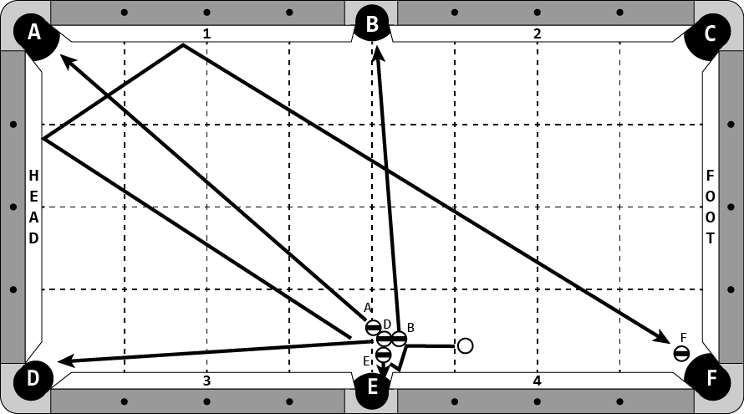

**Cue Ball**

In hand, behind the 3rd diamond.

**Object Balls**

Four object balls are arranged as diagrammed near pocket ‘E’. ‘F’ ball is hanging near pocket ‘F’.

**Objective**

Shoot cue ball into the four ball cluster. Object balls will go into pockets as designated by letters. Cue ball will contact cushion 4, head cushion, and cushion 1 and make ‘F’ ball.

**Special Notes**

Cue ball must contact cushion 4 as the 1st cushion.

# Discipline 1 – Shot 4c – 9 points

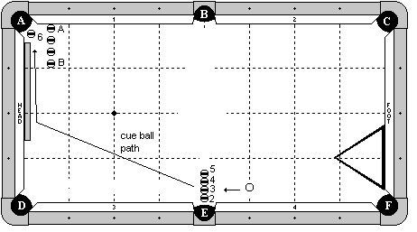

**Cue Ball**

In hand, on or behind the 3rd diamond line.

**Object Balls**

Balls 2,3,4,5 are frozen and adjustable. 6 ball is hanging near pocket ‘A’. 4 blocking balls are along the ½ diamond line, with the first (‘A’) ball frozen to the cushion and 1 ball gaps between the others. A rack is frozen to the foot cushion as diagrammed and adjustable. A cue stick butt is frozen to the head cushion and adjustable.

**Objective**

Shoot the cue ball into the line of balls. The 2 ball will go into pocket ‘E’, the 3 ball into pocket ‘D’, the 4 ball will bank into pocket ‘F’, and the 5 ball will go into pocket ‘B’. The cue ball will follow down table, optionally hitting the long cushion, hit the cue stick butt, and make the 6 ball.

**Special Notes**

The cue ball may not contact any of the blocking balls until after the 6 ball is made. Players selecting this shot will be required to supply the cue stick butt.

On a 7-ft table, blocker balls A through B may be 2 ball widths off the head cushion.

# Discipline 1 – Shot 5a – 10 points

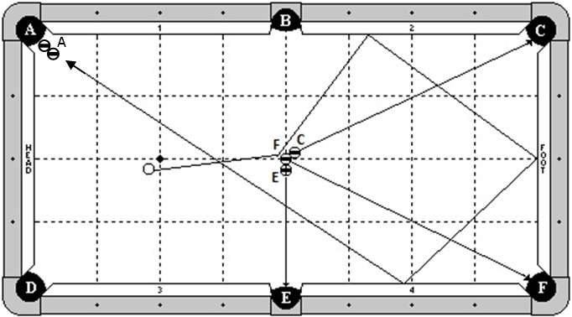

**Cue Ball**

In hand behind the head string.

**Object Balls**

‘F’ ball is exactly in the center of the table. C and E balls are frozen to ball F and adjustable. A ball combo is at pocket A.

**Objective**

Shooting the cue ball to F ball, make all 3 balls as pocket letters designate. The cue ball will then travel 3 rails as diagrammed and make A ball combo.

**Special Notes**

None.

# Discipline 1 – Shot 5b – 10 points

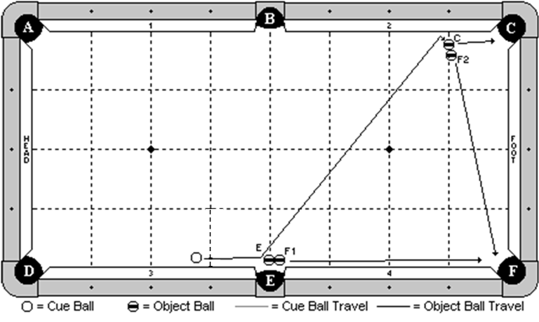

**Cue Ball**

In hand but at least 1 chalk’s width away from object ball.

**Object Balls**

‘E’ and ‘F1’ balls are frozen and adjustable near pocket ‘E’. ‘C’ and ‘F2’ balls are frozen and adjustable as diagrammed, with ‘C’ ball being on the 1st diamond line and no more than 1 ball’s width from the cushion.

**Objective**

Shoot the cue ball into ‘E’ ball, and then carom into cushion 2 and kick into ‘C’ ball. All balls will go as pocket letter designates.

**Special Notes**

None.

# Discipline 1 – Shot 5c – 10 points

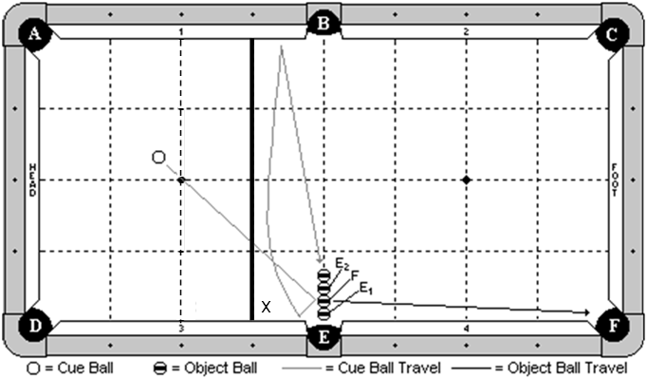

**Cue Ball**

In hand behind 3rd diamond line, as indicated by line X.

**Object Balls**

All four object balls are in a straight line, parallel to the head and foot cushions. The object ball closest to pocket E ('E1') has its edge even with the edge of the cushion.

**Objective**

Shoot cue ball to 'F' ball. 'F' ball will make in pocket 'F' and 'E1' ball will make in pocket 'E'. Cue ball will contact cushion 3, bank across to cushion 1, and come back, making the two ball combination ('E2' ball will make in pocket 'E'). The ball closest to the center of the table does not have to be made.

**Special Notes**

None.

**DISCIPLINE**

**2**

**SPECIAL ARTS**

# Discipline 2 – Shot 1a – 6 points

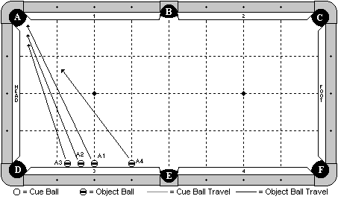

**Cue Ball**

None.

**Object Balls**

4 balls are placed frozen to cushion 3 as diagrammed. ‘A4’ ball is on the 3rd diamond line. ‘A1’ ball is on the 2nd diamond line. ‘A1’, ‘A2’ and ‘A3’ balls are spaced with 1 ball gaps between them.

**Objective**

Shoot ‘A4’ ball towards pocket ‘A’. Quickly shoot balls ‘A1’, ‘A2’, and ‘A3’ in order into pocket ‘A’. The balls will go into pocket ‘A’ in numerical order as indicated by their ball number.

**Special Notes**

It is recommended that players use balls in numerical sequence for this shot. It is okay for the balls to contact each other as they are rolling, provided that they go into the pocket in the following order: ‘A1’, ‘A2’, ‘A3’, ‘A4’.

# Discipline 2 – Shot 1b – 6 points

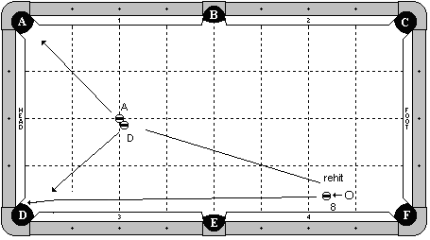

**Cue Ball**

In hand behind the 2nd diamond line.

**Object Balls**

8 ball in hand behind the 2nd diamond line. ‘A’ ball on the head spot. ‘D’ ball frozen to ‘A’ ball and adjustable.

**Objective**

Shoot the cue ball into the 8 ball. Re-hit the cue ball into ‘D’ ball, causing the ‘D’ and ‘A’ ball to be made as pocket letter designates. The 8 ball will go into pocket ‘D’ after ‘D’ ball, no additional contact by object balls are allowed.

**Special Notes**

The 8-ball must go into pocket D without an additional hit by the cue ball.

# Discipline 2 – Shot 1c – 6 points

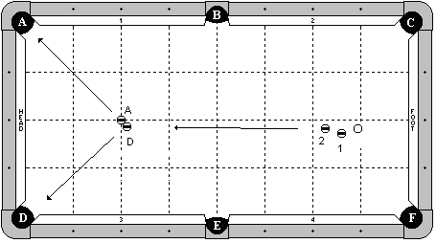

**Cue Ball**

In hand, exactly 3 ball’s width from the 2 ball.

**Object Balls**

2 ball is in hand behind the 2nd diamond line, exactly 3 ball’s width from the cue ball. 1 ball is centered between the cue ball and 2 ball, and is ½ ball offset in either direction. ‘A’ ball on the head spot. ‘D’ ball frozen to ‘A’ ball and adjustable.

**Objective**

In one forward motion stroke, shoot the cue stick through the cue ball and into the 2 ball. The 2 ball will travel forward and make ‘D’ and ‘A’ ball s as pocket letter designates.

**Special Notes**

This shot must be performed in one continuous forward motion. Decision of the table judge is final.

# Discipline 2 – Shot 2a – 7 points

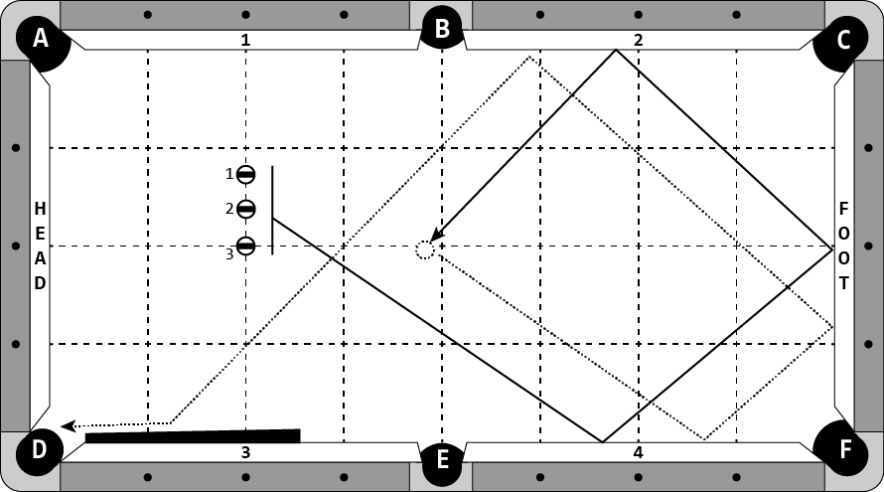

**Cue Ball**

None.

**Object Balls**

3 ball is on the head spot. 1 and 2 balls are in hand along the head string, between the 3 ball and cushion 1.

**Objective**

Hit balls 1, 2, and 3, in order, so they each contact cushion 4, foot cushion, and cushion 2. While they are still moving, hit the balls again, in order, so they contact the same 3 rails and go in to pocket D, possibly with the help of the cue butt. The balls must go in numerical order.

**Special Notes**

The balls may not collide until after the 3 ball is hit a second time. No ball may stop moving during the shot. Table judge’s decision is final.

Players are encouraged to use balls in numerical sequence to aid in judging of the shot.

# Discipline 2 – Shot 2b – 7 points

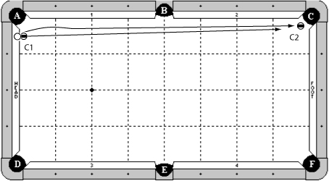

**Cue Ball**

On head cushion, balanced on top of of the cushion and the ‘C1’ ball.

**Object Balls**

‘C1’ ball is in hand, frozen to the head cushion within 1 diamond of pocket ‘A’. ‘C2’ ball is hanging in pocket ‘C’.

**Objective**

Shoot cue ball off of ‘C1’ ball going over ‘C1’ ball and causing ‘C1’ ball to roll down the table. Cue ball will pocket ‘C2’ ball. ‘C1’ ball will also go into pocket ‘C’.

**Special Notes**

Extra contact between cue ball and ‘C1’ ball are not allowed.

# Discipline 2 – Shot 2c – 7 points



**Cue Ball**

In hand behind 3rd diamond line, as indicated.

**Object Balls**

The 1 ball is a special stacking ball near pocket E. The 2 ball is frozen to the 1 ball. The 9 ball is balanced on top of the 1 ball.

A cue stick is laying with the tip end balanced on the rail top. The cue stick must cross the rail within one half diamond or be on top of pocket ‘B’. The butt end of the cue stick may not be extend past the 1st diamond line from cushion 3 and 4.

**Objective**

Shoot the cue ball into the 1 ball. The 1 ball will go into pocket E and the 2 ball will go into pocket F. The cue ball will travel 2 cushions, hit the stick, and make the 9 ball.

**Special Notes**

None.

# Discipline 2 – Shot 3a – 8 points

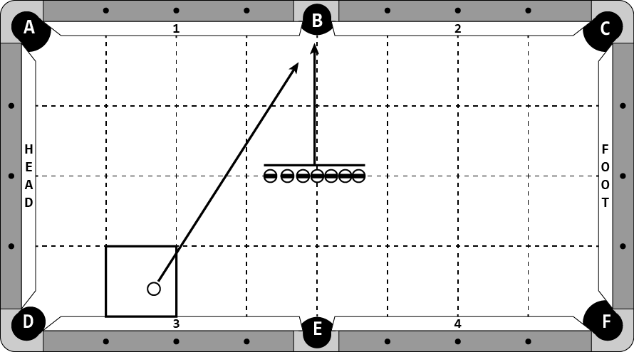

**Cue Ball**

In hand, within the indicated zone.

**Object Balls**

A row of 7 object balls are lined up on the centerline of the table. The middle ball is on the center spot. The other 6 balls are adjustable on the centerline of the table.

**Objective**

Shoot the cue ball towards pocket ‘B’. Before it gets there, shoot the row of 7 balls into pocket ‘B’. The cue ball will go into pocket ‘B’ after all object balls have gone in to pocket ‘B’.

**Special Notes**

Extra ball collisions are allowed.

If the side pocket does not accept 8 balls, one object ball will be removed from the shot for a total of 6 object balls and the cue ball.

# Discipline 2 – Shot 3b – 8 points

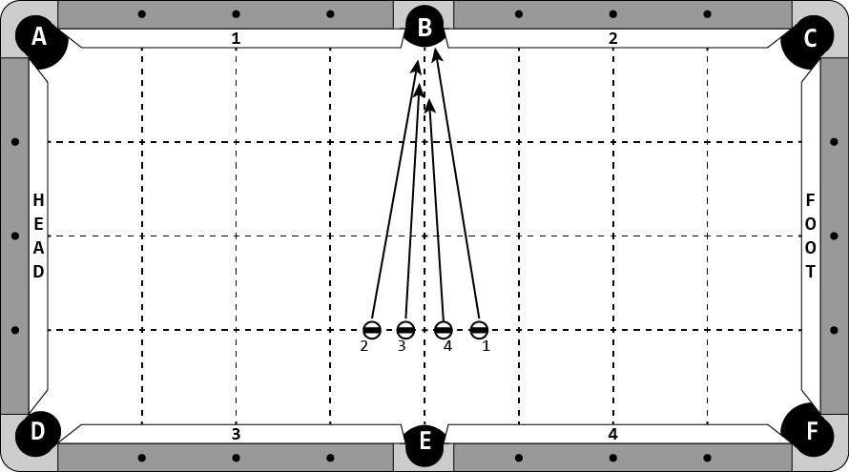

**Cue Ball**

None.

**Object Balls**

Four object balls are in hand along the 1st diamond line. The 2 and 3 balls are to the left of the centerline and the 4 and 1 balls are to the right of the centerline.

**Objective**

Shoot the balls from left to right towards pocket ‘B’, in the order of 2, 3, 4, 1. The balls will go in to pocket ‘B’ in the order of 1, 2, 3, 4.

**Special Notes**

Extra ball collisions are allowed.

It is recommended the player uses balls in numerical order to aid in judging of this shot.

Table judge’s decision is final on the order of balls pocketed.

# Discipline 2 – Shot 3c – 8 points

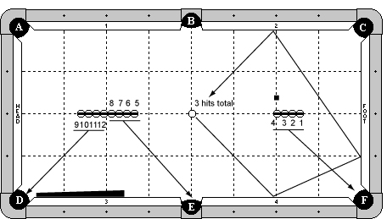

**Cue Ball**

On center spot.

**Object Balls**

1-4 balls frozen on center line with 4B on spot. 5-8 balls frozen on center line. 9-12 balls frozen on center line. 8B and 12B frozen, splitting the spot. Cue stick butt frozen to cushion 3. A piece of chalk is on the foot string, even with the 4B and 1 ball's width away.

**Objective**

Shoot CB around the chalk. Shoot 1,2,3,4 balls into pocket F in order. Re-hit CB around the chalk. Shoot 5,6,7,8 balls into pocket E in order. Re-hit CB around chalk so it will eventually go into pocket D. Shoot 9-12 balls into pocket D in order before CB gets there.

**Special Notes**

Only CB may hit cue stick butt. Chalk may not be contacted by any means. CB may never stop. No balls may be disturbed except the ball being shot. Balls will be pocketed in the following order: 1-12, CB. Balls may not hang up and be made by the next ball.

There is no requirement to shoot any balls left-handed, however, the player may do so at their own discretion.

# Discipline 2 – Shot 4a – 9 points maximum

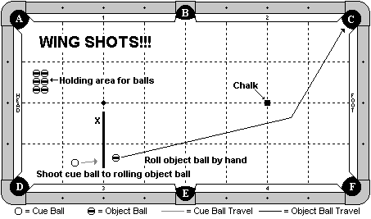

**Cue Ball**

Starts in the player’s hand.

**Object Balls**

Object balls start on the table as diagrammed. There are a total of 9 object balls on the table – 1 in hand and 8 in the holding area. The diagram has not been updated and shows 6 object balls in the holding area. Player will start with one object ball and place it in his hand along with the cue ball. A chalk cube is aligned as diagrammed and placed on the foot spot.

**Objective**

Roll the object ball down the table as diagrammed. Position the cue ball behind the head string. Shoot the cue ball into the rolling object ball and make it in pocket ‘C’. Repeat with 2 more object balls. Note: An attempt consists of 3 wing shots.

**Special Notes**

The object ball must be rolling when hit by the cue ball. The object ball must be hit by the cue ball before it hits the foot cushion. No abort rolls. The chalk may not be hit by the object ball. Use of a guide when rolling the object ball is not allowed.

**Special Scoring**

Make 1 wing shot: 3 points

Make 2 wing shots: 6 points

Make 3 wing shots: 9 points

Players are given 3 attempts with 3 object balls for each attempt.

Note: Best score of 3 attempts will be counted for final score.

# Discipline 2 – Shot 4b – 9 points maximum

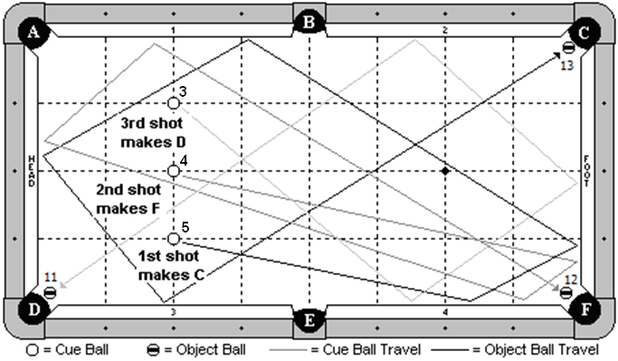

**Cue Ball**

None.

**Object Balls**

Three object balls are placed on the head string, with the center ball on the head spot. It is recommended that the player use the 5,4 & 3 balls as diagrammed. Three other object balls are placed near their corresponding pockets. It is recommended that the player use the 13, 12, & 11 balls as diagrammed.

**Objective**

Shoot the 5 ball first, 5 cushions as diagrammed, to make the 13 ball. Shoot the 4 ball second, 4 cushions as diagrammed, to make the 12 ball. Shoot the 3 ball third, 3 cushions as diagrammed, to make the 11 ball.

**Special Notes**

The player will be timed on this shot. The clock will start when the 5 ball is struck and it will stop when the 3 ball is struck. Players have a maximum of 4 seconds to perform this shot.

**Special Scoring**

Make any 1 ball: 3 points

Make any 2 balls: 6 points

Make any 3 balls: 9 points

Players are given three attempts. The highest scoring attempt will be used.

# Discipline 2 – Shot 4c – 9 points maximum

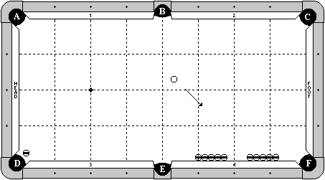

**Cue Ball**

In hand.

**Object Balls**

One object ball hanging near pocket ‘D’.

Two rows of 5 object balls are frozen against cushion 4 with exactly a 4 ball gap in between them. End balls may not be past the point of pocket ‘F’ or ‘E’.

**Objective**

Shoot the CB through the gap around 3 rails. Re-hit the moving CB 3 more times through the gap around 3 rails. After the 3rd re-hit, the cue ball will make ‘D’ ball in pocket ‘D’.

**Special Notes**

The cue ball must be moving when it is re-hit each of the three times.

The rows of blocker balls may not be contacted by any means during the shot.

**Special Scoring**

First hit through the gap and CB goes three rails. No points awarded yet.

First re-hit through the gap and CB goes three rails: 3 points.

Second re-hit through the gap and CB goes three rails: 6 points.

Third re-hit through the gap, CB goes three rails, and must make of OB in pocket D: 9 points

*Examples*: If a player successfully re-hits the CB and goes 3 rails the first time, but misses the second time in any way, the attempt is scored as 3 points. If a player successfully re-hits the CB and goes 3 rails the 2nd time, but misses the 3rd time in any way, the attempt is scored as 6 points.

The CB must hit cushions 4, foot, and 2 for points to be awarded for the hit. Hitting the point of pocket ‘C’ such that the CB re-hits the foot cushion does not count as a successful hit. Table judge’s decision is final.

Players are given three attempts. The highest scoring attempt will be used.

# Discipline 2 – Shot 5a – 10 points

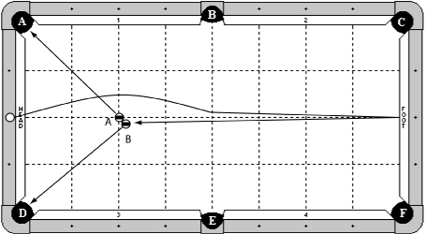

**Cue Ball**

On top of a piece of chalk, on the rail. The chalk must be aligned with centerline of the table.

**Object Balls**

‘A’ ball on head spot. ‘B’ ball in hand, but frozen to ‘A’ ball.

**Objective**

Shoot cue ball over ‘A’ and ‘B’ balls. Cue ball will contact foot cushion and come back to hit ‘B’ ball. ‘A’ ball will be made in pocket ‘A’ and ‘B’ ball will be made in pocket ‘D’.

**Special Notes**

Cue ball may not contact ‘A’ or ‘B’ balls prior to hitting foot cushion.

Multiple cue ball contacts with ‘A’ or ‘B’ balls are allowed.

Cue ball may not contact any other cushion besides foot cushion prior to contacting ‘B’ ball.

The chalk must stay on the rail.

# Discipline 2 – Shot 5b – 10 points

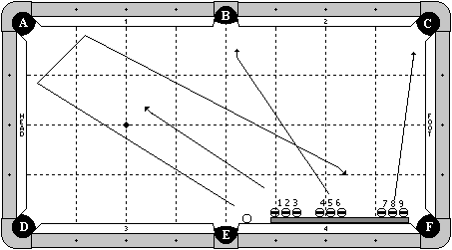

**Cue Ball**

In hand between pockets ‘E’ and ‘F’, frozen to either the cushion or cue stick.

**Object Balls**

Object balls 1 through 9 are in hand between pockets ‘E’ and ‘F’, frozen to either the cushion or cue stick. All balls (cue ball and object balls) must be in the order in which they are diagrammed. A cue stick butt is frozen to the cushion as diagrammed.

**Objective**

Shoot the cue ball 2 cushions as diagrammed. While the cue ball is rolling, shoot the 1,2,3 balls in pocket ‘A’, 4,5,6 balls in pocket ‘B’, and 7,8,9 balls in pocket ‘C’. The cue ball will then go into pocket ‘F’, possibly with the help of the cue stick butt.

**Special Notes**

All of the balls must be struck and pocketed in numerical order as diagrammed. The cue ball does not have to go in last, but the 9 ball must pass in front of the cue ball. Decision of the table judge is final. No balls may be disturbed except the ball being struck. It is recommended that the player use object balls in numerical order. Players selecting this shot will be required to supply the cue stick butt.

# Discipline 2 – Shot 5c – 10 points

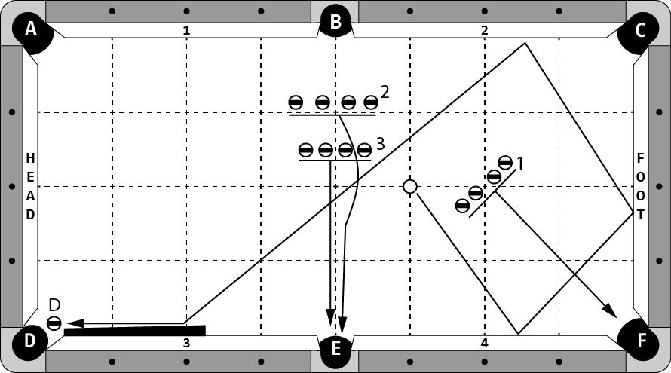

**Cue Ball**

In hand, on long centerline of table.

**Object Balls**

Three rows of four object balls are placed as diagrammed. Object balls within a row must be within 1 chalk width of adjacent balls in the same row.

Row 1 is placed in line with pockets E and C, centered on the foot spot.

Row 2 is in hand within diamond of pocket B.

Row 3 is 1-1/2 diamonds from pocket B.

D ball is hanging in pocket D.

A cue butt is frozen to cushion 3.

**Objective**

Shoot cue ball so it hits cushion 4, foot cushion, and cushion 2. While cue ball is moving, shoot one ball from row 1 into pocket F, jump one ball from row 2 into pocket E, and shoot one ball from row 3 into pocket E. Juggle cue ball off the same three cushions and repeat the process 3 more times. The fourth hit on the cue ball will make it travel three cushions and make ‘D’ ball in pocket D, optionally using the cue butt. The last ball in row 3 must be hit before cue ball contacts ‘D’ ball.

**Special Notes**

Cue ball may never stop moving.

Cue ball must always go around object balls in Row 1.

No object ball may be disturbed except for the one being shot.

If the side pocket does not accept 8 balls, one object ball will be removed from each set of balls.

**DISCIPLINE**

**3**

**DRAW SHOTS**

# Discipline 3 – Shot 1a – 6 points

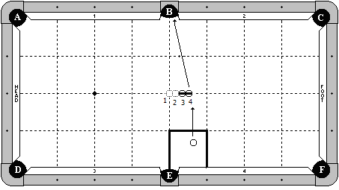

**Cue Ball**

In hand within the indicated zone.

**Object Balls**

Place 4 balls frozen in line along the center line of the table. Remove balls 1 and 2 and leave balls 3 and 4 in place.

**Objective**

Shoot the cue ball into the 4 ball. The 4 ball will go straight into pocket ‘B’.

**Special Notes**

The balls must be exactly straight. Players are not allowed to rotate the balls and adjust the tangent line towards pocket ‘B’.

On a 7-ft table, the object balls will be moved to positions 2 and 3 in the diagram. That is, there will only be a ½ ball space from the center spot of the table (as opposed to the 1-1/2 ball space in the diagram for a 9-ft table).

# Discipline 3 – Shot 1b – 6 points

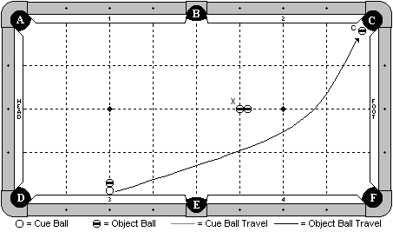

**Cue Ball**

Frozen to the cushion at the 2nd diamond.

**Object Balls**

‘C’ ball is hanging as diagrammed. A blocker ball is frozen to the cue ball on the 2nd diamond line. Two blocker balls are placed frozen on the long center line of the table, with the ball marked ‘X; on the diamond intersection line as indicated by the diagram.

**Objective**

Shoot the cue ball into cushion 3, causing it to escape. The cue ball will curve/draw around the blocker balls and make ‘C’ ball.

**Special Notes**

The three blocker balls may not move by any means until after ‘C’ ball has been made.

# Discipline 3 – Shot 1c – 6 points

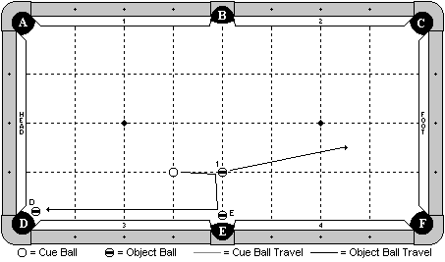

**Cue Ball**

In hand along the 3rd diamond line.

**Object Balls**

1 ball on the diamond intersection line as diagrammed. ‘E’ and ‘D’ balls are hanging near their respective pockets. ‘E’ bal may not be more than 1 ball’s width from the pocket cut.

**Objective**

Shoot the cue ball into the 1 ball. The cue ball will carom over and make ‘E’ ball. It will then draw back and make ‘D’ ball.

**Special Notes**

The 1 ball doesn’t have to be pocketed.

# Discipline 3 – Shot 2a – 7 points

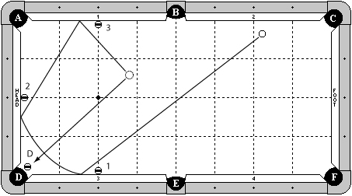

**Cue Ball**

In hand behind the foot string.

**Object Balls**

Three object balls frozen to the cushion at the diamond lines as diagrammed.

‘D’ ball is hanging in pocket D.

**Objective**

Shoot the cue ball three cushions as diagrammed. The cue ball must hit cushion 3 between the 1 ball and pocket ‘D’. The cue ball must hit the head cushion between the 2 ball and pocket ‘D’. The cue ball must hit cushion 1 between the 3 ball and pocket ‘A’. Re-hit the cue ball after it passes the 2nd diamond line to make ‘D’ ball in pocket ‘D’.

**Special Notes**

The blocker balls may not be touched by any means. The trailing edge of the cue ball must pass the 2nd diamond line after hitting cushion 1 (the third rail) before it is re-hit.

# Discipline 3 – Shot 2b – 7 points

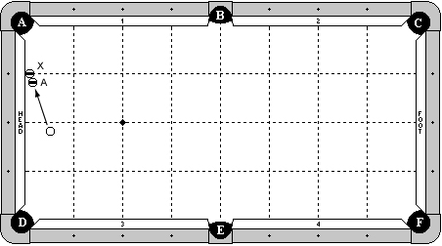

**Cue Ball**

In hand, behind long center line of table.

**Object Balls**

‘X’ ball is frozen to head cushion at the first diamond from pocket ‘A’.

‘A’ ball is frozen to ‘X’ ball, as diagrammed.

**Objective**

Shoot cue ball in to ‘A’ ball. ‘X’ ball will bank away. ‘A’ ball will go in to pocket ‘A’. After contact with ‘A’ ball, cue ball must draw back to contact rail 3 or 4 without hitting another cushion beforehand.

**Special Notes**

‘A’ ball may not be contacted by either ‘X’ ball or CB after the initial hit.

# Discipline 3 – Shot 2c – 7 points

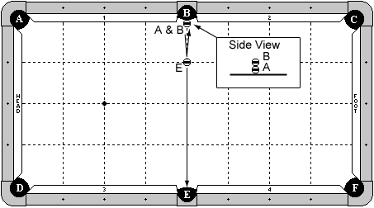

**Cue Ball**

On centerline of the table, with back edge even with cut of pocket ‘B’. A stacking ball may be used as a substitute for the cue ball, as indicated by ball ‘A’ in the diagram.

**Object Balls**

‘E’ ball is on the centerline of the table, 1 diamond from pocket ‘B’. ‘B’ ball is stacked on top of the cue ball.

**Objective**

Shoot cue ball out from underneath ‘B’ ball. Cue ball will make ‘E’ ball in pocket ‘E’, then draw back and make ‘B’ ball.

**Special Notes**

Players may use a ring or washer in order to stack the two balls. If the washer interferes with the shot, it will not be a foul and the result will stand. ‘B’ ball may not contact cue stick as it drops from its stacked position.

# Discipline 3 – Shot 3a – 8 points

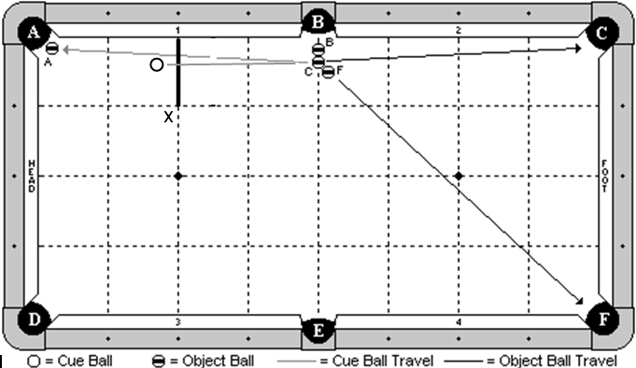

**Cue Ball**

In hand, behind head string as indicated by the diagram.

**Object Balls**

3 ball cluster is adjustable and near pocket ‘B’ as diagrammed. ‘A’ ball is hanging near pocket ‘A’.

**Objective**

Shoot the cue ball into the middle ball of the cluster. The three balls will go as designated by pocket letter. The cue ball will draw back and make ‘A’ ball.

**Special Notes**

None.

# Discipline 3 – Shot 3b – 8 points

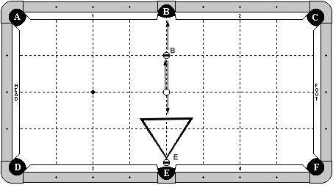

**Cue Ball**

On center spot.

**Object Balls**

‘B’ ball on center line, one diamond away from pocket ‘B’.

‘E’ ball on center line, with back edge even with pocket cut or deeper.

A rack is frozen to ‘E’ ball as diagrammed.

**Objective**

Shoot the cue ball one-handed, jacked up, pocketing ‘B’ ball in pocket ‘B’ and drawing the cue ball back, hitting the rack and pocketing ‘E’ ball in pocket ‘E’.

**Special Notes**

None.

# Discipline 3 – Shot 3c – 8 points

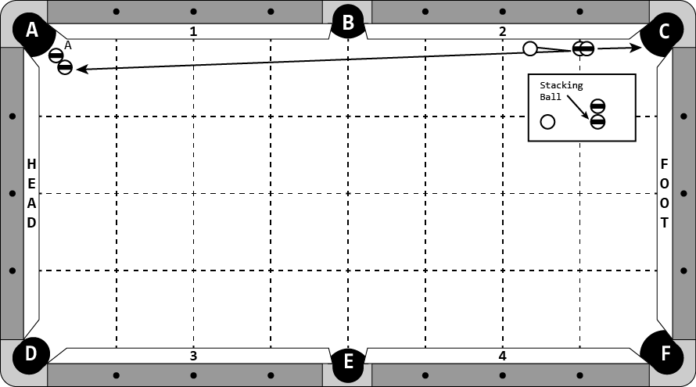

**Cue Ball**

In hand, at least two ball widths from object balls.

**Object Balls**

A stacking ball is on the 1st diamond line from pocket ‘C’. An object ball is stacked on top of this stacking ball. ‘A’ ball is hanging in pocket ‘A’ with a combination/helper ball.

**Objective**

Shoot the cue ball into the stack. Both balls in the stack will go in to pocket ‘C’. Cue ball will draw back and make ‘A’ ball.

**Special Notes**

Players may use a regular ball with a washer in lieu of the stacking ball. If the washer interferes with the shot, whatever the result is will stand.

Cue ball may contact either ball in the stack first.

Cue ball may make ‘A’ ball with or without contacting the combination/helper ball.

# Discipline 3 – Shot 4a – 9 points

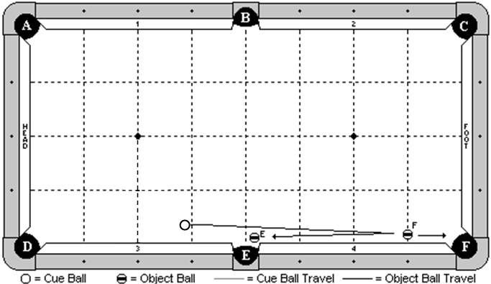

**Cue Ball**

In hand within 1 chalk width of the 3rd diamond line.

**Object Balls**

‘F’ ball is in hand along the 1st diamond line. ‘E’ ball is hanging near pocket ‘E’ and is adjustable.

**Objective**

Shoot the cue ball and make ‘F’ ball in pocket ‘F’. The cue ball will draw back and make ‘E’ ball.

**Special Notes**

The cue ball may contact cushion 4, but no other, until after ‘E’ ball is made.

For a 7-ft table, the cue ball must be on the head string.

# Discipline 3 – Shot 4b – 9 points

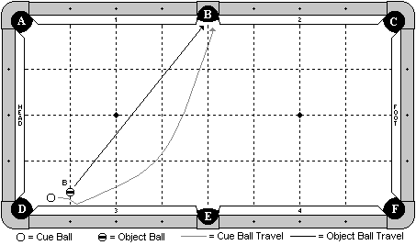

**Cue Ball**

In hand.

**Object Balls**

‘B’ ball is in hand along the 1st diamond line, but may be no more than 1 ball + 1 chalk’s width from the cushion.

**Objective**

Shoot the cue ball into ‘B’ ball. The cue ball will hit cushion 3 and curve around the rolling ‘B’ ball. Both balls will go into pocket ‘B’, cue ball first.

**Special Notes**

The balls may contact each other more than once. Close calls will be at the discretion of the table judge.

# Discipline 3 – Shot 4c – 9 points

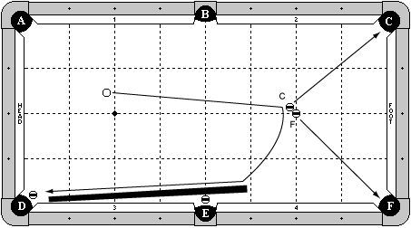

**Cue Ball**

In hand behind head string.

**Object Balls**

‘F’ ball on foot spot. ‘C’ ball in hand frozen to ‘F’ ball. An object ball is hanging in pocket ‘E’ and pocket ‘D’. A cue stick is placed frozen to ball near pocket ‘E’. The end of the butt must be more than 3 diamonds away from foot cushion.

**Objective**

Shoot cue ball in to ‘C’ ball causing ‘C’ ball to go in to pocket ‘C’ and ‘F’ ball to go in to pocket ‘F’. Cue ball will draw back hitting the cue stick and pocketing the hanging ball in pocket ‘E’. Cue ball will continue to draw down the rail to pocket the hanging ball in pocket ‘D’.

**Special Notes**

None.

# Discipline 3 – Shot 5a – 10 points

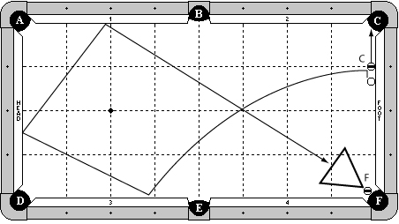

**Cue Ball**

In hand, frozen to the foot cushion, but must be at least 1 ball’s width from the object ball.

**Object Balls**

‘C’ ball frozen to the foot cushion at the 1st diamond. ‘F’ ball hanging in pocket F. A rack is in hand, frozen to ‘F’ ball.

**Objective**

Shoot the cue ball and make ‘C’ ball. The cue ball will draw around the table as indicated, hit the rack, and make ‘F’ ball in pocket F.

**Special Notes**

The cue ball may contact cushion 3 or 4 as the 1st cushion. The cue ball may contact extra cushions near pocket ‘F’. The cue ball may go between the rack and either rail and make ‘F’ ball directly.

On a 7-ft table, the rack is removed and a combination ball is added frozen to the ‘F’ ball.

# Discipline 3 – Shot 5b – 10 points

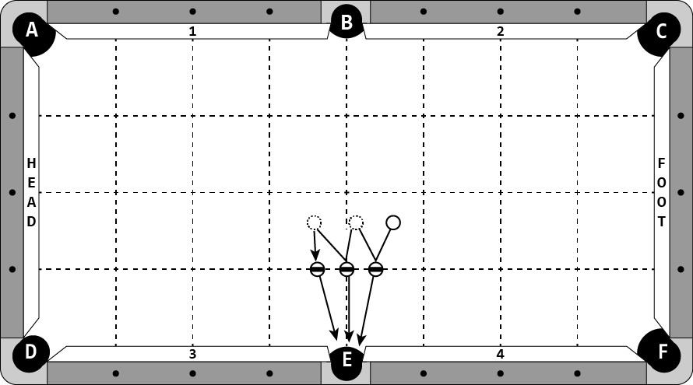

**Cue Ball**

In hand.

**Object Balls**

All object balls are on the 1st diamond line from pocket ‘E’. The middle object ball is on the centerline of the table. The other object balls must be at least one ball width from the middle ball.

**Objective**

Pocket all balls in pocket ‘E’ from left to right. The cue ball may not stop moving until after contacts the third ball. The cue ball may not contact a rail until after it contacts the third ball.

**Special Notes**

None.

# Discipline 3 – Shot 5c – 10 points

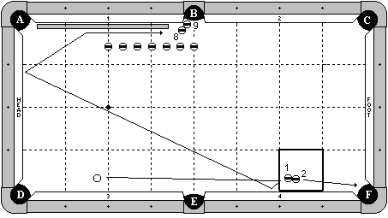

**Cue Ball**

In hand behind the head string.

**Object Balls**

The 1-2 combination is in hand within the indicated zone. The 8-9 combination is near pocket ‘B’ as diagrammed. 7 blocker balls are 3 ball’s width off the cushion. The first ball is on the 2nd diamond line, the last ball is on the center line, and the others are evenly spaced between them. A cue stick butt is frozen to cushion 1.

**Objective**

Shoot the cue ball and make the 2 ball in pocket ‘F’. The cue ball will draw back as diagrammed, hit the cue stick, and make the 8-9 combination.

**Special Notes**

The cue ball does not need to hit cushion 4. It may draw straight back into the head cushion. The blocker balls may not be disturbed by any means until after the cue ball hits the 8 ball. After the cue ball contacts the 1 ball for the first time, the 1 ball may not interfere with the shot. Players selecting this shot will be required to supply the cue stick butt.

**DISCIPLINE**

**4**

**FOLLOW SHOTS**

# Discipline 4 – Shot 1a – 6 points

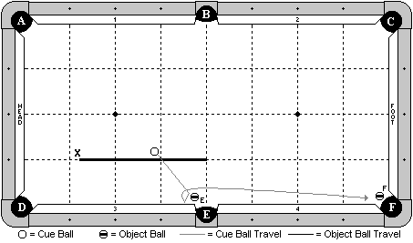

**Cue Ball**

In hand behind the ‘X’ line.

**Object Balls**

‘E’ ball is near pocket ‘E’ and adjustable. ‘F’ ball is hanging near pocket ‘F’.

**Objective**

Shoot the cue ball and make ‘E’ ball. The cue ball will then contact cushion 3, and force follow forward to make ‘F’ ball.

**Special Notes**

The cue ball must contact ball ‘E’ prior to contacting cushion 3. The cue ball must contact cushion 3. It may not make ‘E’ ball and simply carom down the rail to make ‘F’ ball.

# Discipline 4 – Shot 1b – 6 points

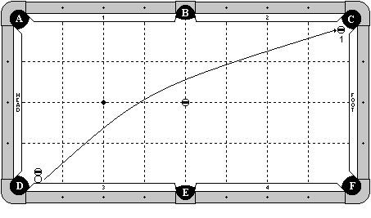

**Cue Ball**

Frozen to the cushion, with the edge aligned with the pocket point.

**Object Balls**

A blocker ball is frozen to the cue ball and perpendicular to cushion 3 (straight out). Another blocking ball is on the center point of the table. The 1 ball is hanging near pocket ‘C’.

**Objective**

Shoot the cue ball into cushion 3, compressing the rail and allowing the cue ball to escape. The cue ball will travel around the center blocking ball as diagrammed, and make the 1 ball.

**Special Notes**

Neither blocking ball may move by any means until after the 1 ball is made.

On a 7-ft table, the blocker ball will be moved 1 ball width towards the foot cushion. That is, the blocker ball will be placed frozen to the diagrammed blocker ball on the centerline towards the foot cushion, and then the diagrammed blocker ball will be removed.

# Discipline 4 – Shot 1c – 6 points

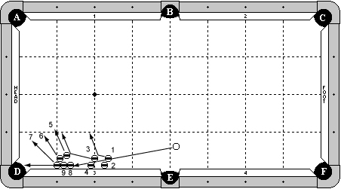

**Cue Ball**

In hand, behind short center line of table.

**Object Balls**

7 ball is frozen to cushion 3 at first diamond from pocket ‘D’.

9 ball is frozen to 7 ball and cushion 3, as diagrammed.

8 ball is frozen to 9 ball and cushion 3, as diagrammed.

6 ball is frozen to 7 ball.

5 ball is frozen to 6 ball.

4 ball is frozen to cushion 3, at least two balls spacing from 8 ball.

3 ball is frozen to 4 ball.

2 ball is frozen to cushion 3 at least one ball spacing from 4 ball.

1 ball is frozen to 2 ball.

**Objective**

Shoot cue ball in to 1 ball. The 1 ball will bank the 2 ball out of the way and carom in to the 3 ball. The 3 ball will bank the 4 ball out of the way and carom in to the 5 ball. The 5, 6, and 7 balls will all clear out of the way. The cue ball will follow forward, hitting the 8 ball and causing the 9 ball to go in pocket ‘D’.

**Special Notes**

The 9 ball may not be contacted by any balls on its way to the pocket.

**\*\*\*It is strongly encouraged players use the 1-9 balls with the 1 ball and 9 ball in the positions as diagrammed so spectators can have a better understanding of the shot.**

# Discipline 4 – Shot 2a – 7 points

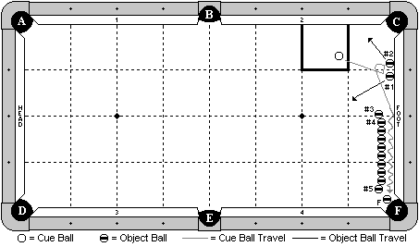

**Cue Ball**

In hand within the indicated zone.

**Object Balls**

Balls 1 & 2 are frozen to the foot cushion and centered around the 1st diamond. ‘F’ ball is hanging near pocket ‘F’. A row of 10 balls is approximately 1 ball’s width off the cushion, but this spacing may be adjusted by the player. The row must be straight (parallel to the foot cushion), with the option of adjusting balls 3, 4, and/or 5. If this option is used, those balls must still remain frozen to the others in the line.

**Objective**

Shoot the cue ball to ball # 1, then carom into ball # 2, and then travel between the row of balls and the cushion. The cue ball will hit at least 4 object balls, and then go on to make ‘F’ ball.

**Special Notes**

The cue ball must hit ball 1 first, then ball 2. The cue ball must make ‘F’ ball. It may not be made by an object ball. If the cue ball comes to a stop and is later helped by another ball coming in contact with the row of balls or the cue ball, the shot is no good. The cue ball must make ‘F’ ball on its own. Decision of the table judge is final.

# Discipline 4 – Shot 2b – 7 points

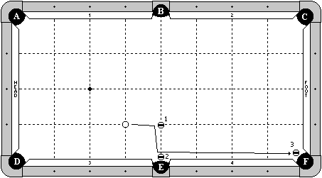

**Cue Ball**

In hand along the 3rd diamond line.

**Object Balls**

1 ball is on the diamond intersection line as diagrammed. 2 & 3 balls are hanging near their respective pockets, no more than one ball width from the cut of the pocket.

**Objective**

Shoot the cue ball into the 1 ball. The cue ball will carom over and make the 2 ball, and then follow down to make the 3 ball.

**Special Notes**

The 1 ball does not have to be made. The 1 ball may not interfere with the shot until after the 3 ball is made.

# Discipline 4 – Shot 2c – 7 points

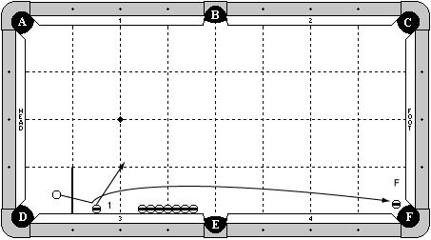

**Cue Ball**

In hand behind first diamond on cushion ‘3’.

**Object Balls**

‘1’ ball frozen to cushion 3 at 1 ½ diamonds from pocket ‘D’.

‘F’ ball hanging in pocket ‘F’.

A row of 7 object balls is frozen to cushion 3, centered on the 3rd diamond.

**Objective**

Shoot cue ball into 1 ball. The cue ball will curve around the blocking balls and make ‘F’ ball in pocket ‘F’.

**Special Notes**

‘F’ ball must be made by the cue ball.

Blocking balls may not be contacted by any means until after ‘F’ ball is made.

Cue ball may contact cushion 3 before passing blocker balls.

# Discipline 4 – Shot 3a – 8 points

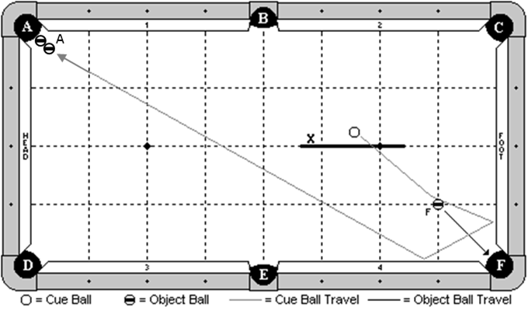

**Cue Ball**

In hand behind the indicated line.

**Object Balls**

‘F’ ball on the 1-1 diamond intersection line. ‘A’ ball combo is hanging near pocket ‘A’.

**Objective**

Shoot the cue ball and make ‘F’ ball in pocket ‘F’. The cue ball will follow forward 2 cushions as diagrammed, and make ‘A’ ball combo in pocket ‘A’.

**Special Notes**

None.

# Discipline 4 – Shot 3b – 8 points

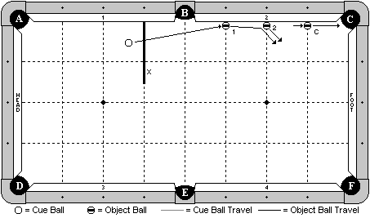

**Cue Ball**

In hand behind the indicated line.

**Object Balls**

1 and 2 balls are on their indicated diamond lines and frozen to the cushion. ‘C’ ball is on the 1st diamond and adjustable along that line.

**Objective**

Shoot the cue ball into the 1 ball. The 1 ball will hit the 2 ball and both will clear. The cue ball will follow forward and make ‘C’ ball.

**Special Notes**

‘C’ ball may not be contacted by any ball other than the cue ball.

# Discipline 4 – Shot 3c – 8 points

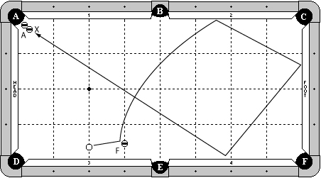

**Cue Ball**

In hand, along second diamond line.

**Object Balls**

‘F’ ball exactly two balls width from cushion 3 on third diamond line.

‘A’ ball is hanging in pocket ‘A’. ‘X’ ball is frozen to ‘A’ ball as a helper.

**Objective**

Shoot cue ball in to ‘F’ ball. ‘F’ ball will go in to pocket ‘F’. Cue ball will contact cushion 2, foot cushion, and cushion 4 and make ‘A’ ball in pocket ‘A’.

**Special Notes**

Cue ball may contact extra cushions by pocket ‘A’.

# Discipline 4 – Shot 4a – 9 points

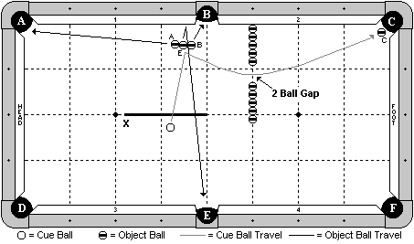

**Cue Ball**

In hand behind the indicated line.

**Object Balls**

‘B’ and ‘E’ balls are frozen and exactly 2 ball’s width off the cushion, and adjustable left or right. ‘A’ ball is adjustable and frozen to ‘E’ ball. ‘C’ ball is hanging near pocket ‘C’. A line of 10 object balls are along the 3rd diamond line. A gap of 2 ball’s width is between the first 5 balls and the last 5 balls.

**Objective**

Shoot the cue ball and make the three balls as pocket letter designates. The cue ball will travel the indicated path through the gap, and follow forward to make ‘C’ ball.

**Special Notes**

The blocking balls may not be touched by any means until after ‘C’ ball is made.

# Discipline 4 – Shot 4b – 9 points

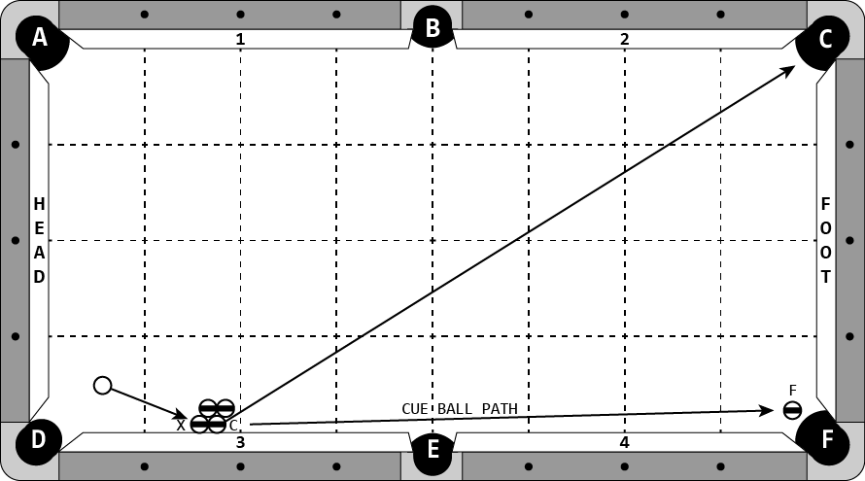

**Cue Ball**

In hand.

**Object Balls**

‘F’ ball is hanging in pocket ‘F’. A cluster of 4 balls is in hand, as diagrammed.

**Objective**

Shoot cue ball into ‘X’ ball. ‘C’ ball will bank into pocket ‘C’. Cue ball will follow up the rail and make ‘F’ ball.

**Special Notes**

Cue ball may not contact any balls between the initial hit on ‘X’ ball and making the ‘F’ ball.

Cue ball must make ‘F’ ball.

# Discipline 4 – Shot 4c – 9 points

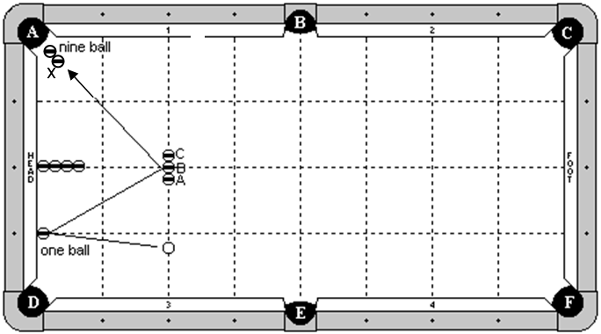

**Cue Ball**

In hand along the 2nd diamond line.

**Object Balls**

1 ball frozen to the head cushion at the 1st diamond. ‘A’, ‘B’, and ‘C’ balls are frozen in line along the head string with ‘B’ ball on the head spot. 4 blocker balls are along the 2nd diamond line with the first ball frozen to the cushion. The 9 ball is hanging near pocket ‘A’. ‘X’ ball is frozen to the 9 ball as a helper.

**Objective**

Shoot the cue ball into the 1 ball. The cue ball will double kiss back into the line of three balls (A,B,C), and then follow forward to make the 9 ball.

**Special Notes**

The cue ball may not contact any cushions except possibly the head cushion or cushion 1 near pocket ‘A’. The cue ball may contact any combination of ‘A’,’B’,’C’ balls. The 4 blocker balls may not be contacted by the cue ball until after the 9 ball is made.

# Discipline 4 – Shot 5a – 10 points

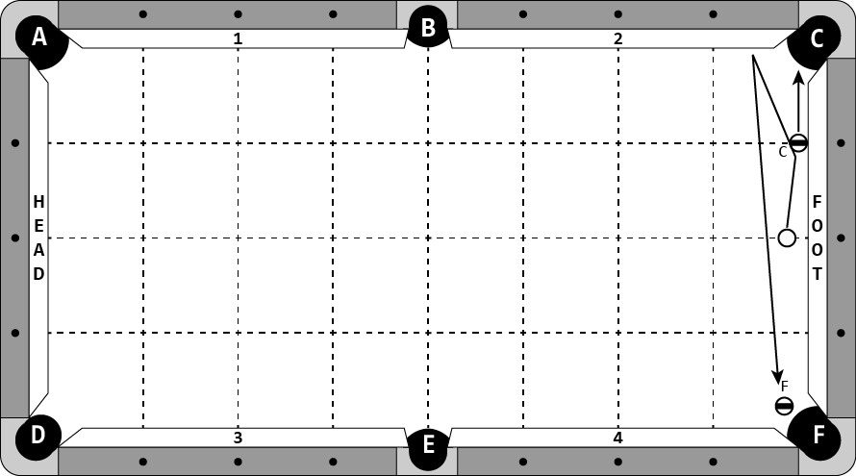

**Cue Ball**

In hand, along the 2nd diamond line.

**Object Balls**

‘C’ ball is frozen to the rail at the 1st diamond. ‘F’ ball is hanging in pocket ‘F’.

**Objective**

Shoot the cue ball, pocketing ‘C’ ball. Cue ball will contact cushion 2 and then make ‘F’ ball.

**Special Notes**

Cue ball may contact foot cushion before or after contacting ‘C’ ball.

# Discipline 4 – Shot 5b – 10 points

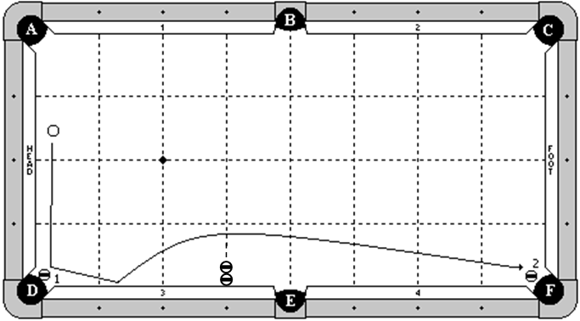

**Cue Ball**

In hand behind the long center line of the table.

**Object Balls**

1 ball is hanging near pocket ‘D’ and adjustable. 2 ball is hanging near pocket ‘F’. Two blocker balls are frozen in line along the 3rd diamond.

**Objective**

Shoot the cue ball into the 1 ball, making it in pocket ‘D’. The cue ball will hit cushion 3, bounce out and around the two blocker balls, and make the 2 ball.

**Special Notes**

The blocker balls may not be hit by any means until after the 2 ball is made.

# Discipline 4 – Shot 5c – 10 points

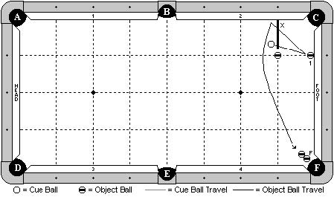

**Cue Ball**

In hand behind line ‘X’, as diagrammed.

**Object Balls**

Object ball ‘1’ is frozen to the foot cushion at 1 diamond segment.

Blocking ball is placed at the 1x1 diamond intersection.

Two ball combination is hanging by pocket ‘F’.

**Objective**

Shoot cue ball into 1 ball. Cue ball will double kiss back off cushion 2 and curve around blocking ball, hit the two ball combination, and pocket ‘F’ ball.

**Special Notes**

Cue ball may not contact foot cushion before contacting cushion 2.

The blocking ball may not be contact by any means until after ‘F’ ball is made.

Extra contacts between the 1 ball and cue ball are not allowed.

**DISCIPLINE**

**5**

**BANK / KICK SHOTS**

# Discipline 5 – Shot 1a – 6 points

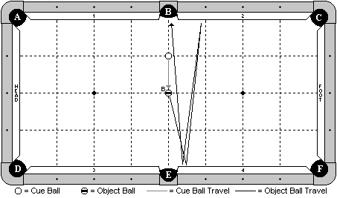

**Cue Ball**

On the diamond intersection line as diagrammed.

**Object Balls**

‘B’ ball on the exact center spot of the table.

**Objective**

Shoot the cue ball into ‘B’ ball. ‘B’ ball will bank three cushions as diagrammed (cushion 4, cushion 2, cushion 4), and go into pocket ‘B’.

**Special Notes**

None.

# Discipline 5 – Shot 1b – 6 points

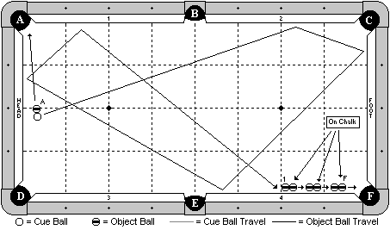

**Cue Ball**

In hand, frozen to ‘A’ ball.

**Object Balls**

‘A’ ball in hand along the long center line. 6 balls are lined up near pocket ‘F’. The first ball (left most ball in the diagram) in each group is on the table, and the other ball is on top of a new chalk cube (well up). Each group of balls must be at least 1 ball’s width apart. The entire line may not be more than 1 chalk’s width off the cushion. The last ball (‘F’) may not have its forward edge past the pocket point.

**Objective**

Shoot the cue ball making ‘A’ ball in pocket ‘A’. The cue ball will travel 5 cushions as diagrammed, hit the 1 ball (the first ball in the line), and start a chain reaction. Each ball on the chalk will fall and hit the next ball in line, until the ‘F’ ball goes into pocket ‘F’.

**Special Notes**

The cue ball may contact an extra cushion near the 1 ball. The cue ball must contact the 1 ball first. The cue ball may contact the ball on the chalk that is frozen to the 1 ball, but it must contact the 1 ball first.

# Discipline 5 – Shot 1c – 6 points

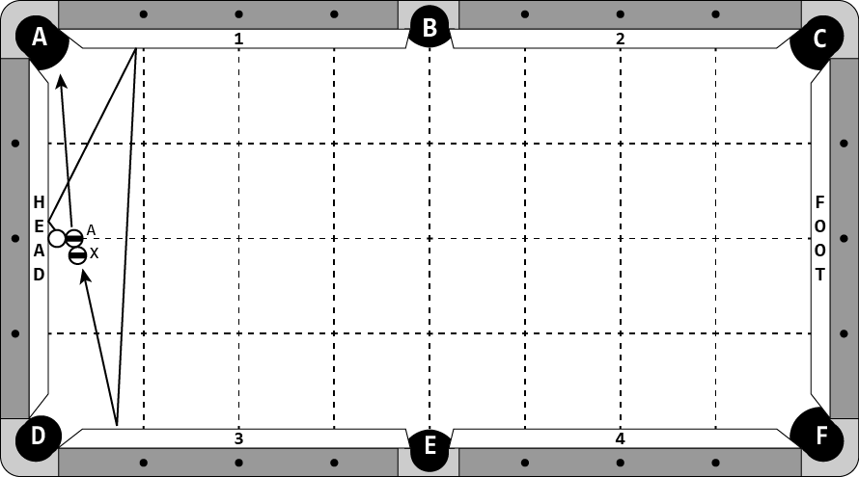

**Cue Ball**

Frozen to head cushion at the 2nd diamond.

**Object Balls**

‘A’ ball is frozen to cue ball and on the 2nd diamond line.

‘X’ ball is in hand, frozen to ‘A’ ball.

**Objective**

Shoot cue ball into head cushion. Cue ball will hit cushion 1 and cushion 3, then the ‘X’ ball, causing ‘A’ ball to go in pocket ‘A’.

# Discipline 5 – Shot 2a – 7 points

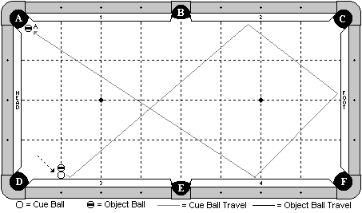

**Cue Ball**

Frozen to the cushion at the 1st diamond.

**Object Balls**

‘A’ ball hanging near pocket ‘A’. A blocker ball is along the 1st diamond and frozen to the cue ball.

**Objective**

Shoot the cue ball in the direction of the arrow, causing it to escape out. The cue ball will the travel around the table as diagrammed, and make ‘A’ ball.

**Special Notes**

The blocker ball may not move by any means until after ‘A’ ball is made.

# Discipline 5 – Shot 2b – 7 points

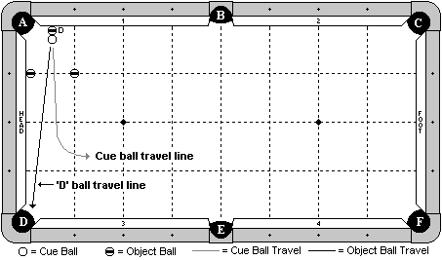

**Cue Ball**

Along the ½ diamond line, frozen to ‘D’ ball.

**Object Balls**

‘D’ ball along the ½ diamond line, frozen to the cushion. A blocker ball is on the 1st diamond line, frozen to the head cushion. Another blocker ball is on the 1-1 diamond intersection line.

**Objective**

Shoot the cue ball and cause ‘D’ ball to bank back into pocket ‘D’. The cue ball must come out between the two blocker balls.

**Special Notes**

The blocker balls may not be contacted by any means until after ‘D’ ball is made. The cue ball and ‘D’ ball may contact each other multiple times.

# Discipline 5 – Shot 2c – 7 points

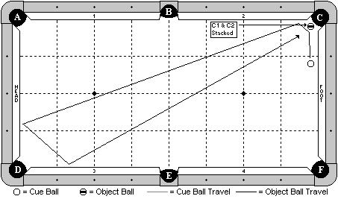

**Cue Ball**

In hand, behind 1st diamond line from pocket ‘C’.

**Object Balls**

A stacker ball is hanging near pocket ‘C’. An object ball is balanced on top of it.

**Objective**

Shoot the cue ball into the stacker ball, making it in pocket ‘C’ and causing the object ball to fall in place. The cue ball will travel three cushions as diagrammed, and make the object ball in pocket ‘C’.

**Special Notes**

None.

# Discipline 5 – Shot 3a – 8 points

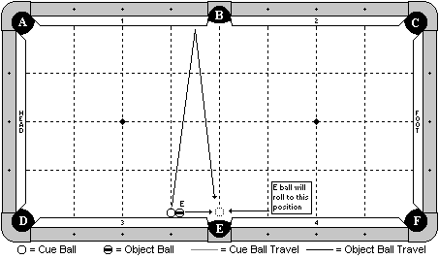

**Cue Ball**

Frozen to the cushion at the 3rd diamond.

**Object Balls**

‘E’ ball frozen to the cushion and to the cue ball.

**Objective**

Shoot the cue ball to bank one rail as diagrammed. ‘E’ ball will roll in front of pocket ‘E’. The cue ball will bank back into ‘E’ ball and make it in pocket ‘E’.

**Special Notes**

None.

# Discipline 5 – Shot 3b – 8 points

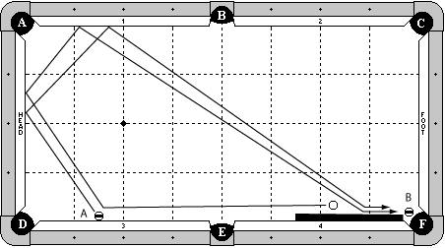

**Cue Ball**

In hand, behind the 2nd diamond line.

**Object Balls**

‘A’ ball is frozen to cushion 3 at the 1-1/2 diamond line. ‘B’ ball is hanging in pocket ‘F’. A cue butt is frozen to cushion 4.

**Objective**

Shoot the cue ball into ‘A’ ball. Cue ball will contact head cushion and cushion 1, optionally contact the cue butt, and pocket ‘B’ ball. ‘A’ ball will also contact head cushion and cushion 1, optionally contact the cue butt and go in to pocket ‘F’.

**Special Notes**

The cue ball may not contact ‘A’ ball after initial hit.

# Discipline 5 – Shot 3c – 8 points

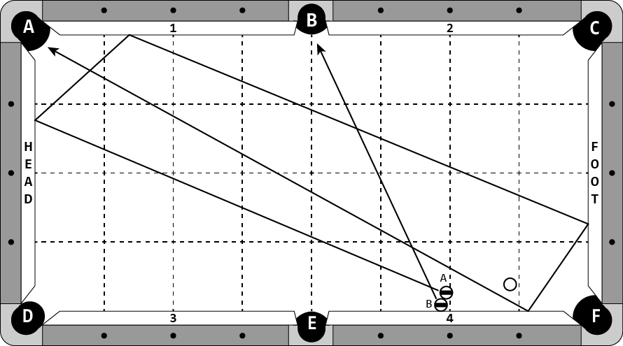

**Cue Ball**

In hand.

**Object Balls**

‘B’ ball is frozen to cushion 4. ‘A’ ball is frozen to ‘B’ ball.

**Objective**

Shoot cue ball into ‘A’ ball. ‘B’ ball will bank into pocket ‘B’. ‘A’ ball will bank four rails into pocket ‘A’.

**Special Notes**

Cue ball may not contact either ball after initial hit.

# Discipline 5 – Shot 4a – 9 points

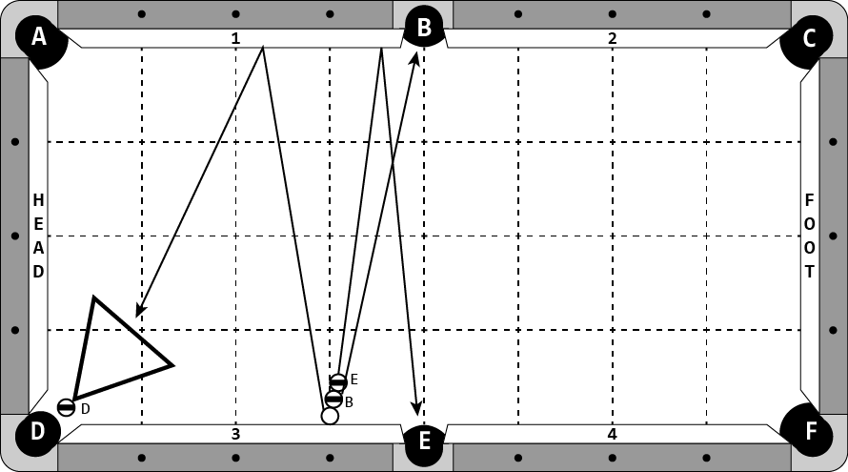

**Cue Ball**

Frozen to cushion 3 at the 3rd diamond.

**Object Balls**

‘B’ ball is frozen to cue ball. ‘E’ ball is frozen to ‘B’ ball. Cue ball, ‘B’ ball, and ‘E’ ball are in a straight line. ‘D’ ball is hanging in pocket ‘D’. A rack is frozen to ‘D’ ball.

**Objective**

Shoot into the line of balls. ‘E’ ball will bank into pocket ‘E’. ‘B’ ball will go directly into pocket ‘B’. Cue ball will bank off cushion 1, hit the rack, making ‘D’ ball.

**Special Notes**

Extra contact between balls is not allowed.

Cue ball may contact head cushion or cushion 3 and pocket ‘D’ ball with or without hitting the rack.

# Discipline 5 – Shot 4b – 9 points

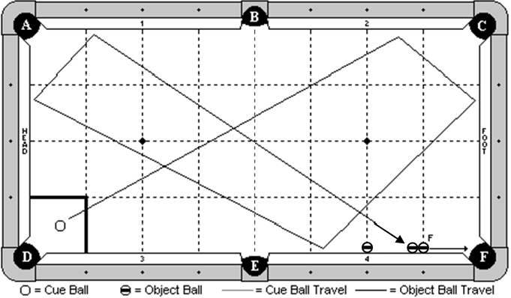

**Cue Ball**

In hand within the indicated zone.

**Object Balls**

‘F’ ball is frozen to cushion on 1st diamond line with combo ball frozen to F ball and rail. A blocker ball is frozen to cushion on 2nd diamond line as diagrammed.

**Objective**

Shoot the cue ball 5 cushions as diagrammed, and make ‘F’ ball in pocket ‘F’.

**Special Notes**

Blocker ball may not be contacted until F ball is made.

# Discipline 5 – Shot 4c – 9 points

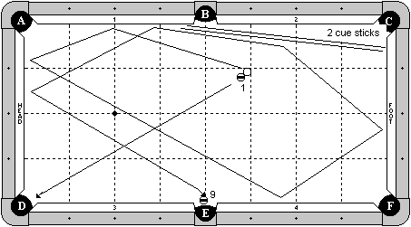

**Cue Ball**

In hand behind the B-E center line (on the foot cushion side of the table).

**Object Balls**

1 ball in hand, frozen to the cue ball, and also must be to the right of the B-E center line. 9 ball is hanging near pocket ‘E’. Two cue sticks are placed on the table as diagrammed, with their butt ends near the foot cushion. Players have the option of using both cue sticks as diagrammed, or just one cue stick.

**Objective**

Shoot the cue ball to make the 1 ball in pocket ‘D’. The cue ball will travel 4 cushions as diagrammed, hit the cue stick, then travel 2 more cushions and make the 9 ball.

**Special Notes**

Players selecting this shot will be required to supply the 2 cue sticks.

# Discipline 5 – Shot 5a – 10 points

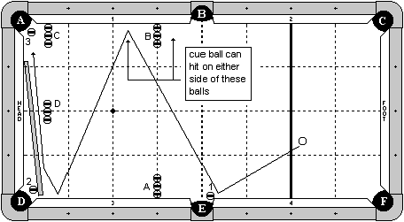

**Cue Ball**

In hand behind foot string.

**Object Balls**

1, 2, and 3 balls hanging in their respective pockets.

Four sets of three blocker balls are positioned as diagrammed. Set A is frozen to cushion 3 one diamond from pocket ‘E’. Set B is frozen to cushion 1 one diamond from pocket ‘B’. Set C is frozen to cushion 1 at one-half diamond from pocket ‘A’. Set D is one-half diamond from head cushion centered along the long center line of the table.

A cue butt is positioned as diagrammed, frozen to ball 2.

**Objective**

Shoot cue ball into 1 ball, pocketing it in pocket ‘E’. Cue ball will hit cushion 1 then cushion 3. Cue ball will then hit the cue butt, pocketing 2 ball in pocket ‘D’, roll down the cue butt and pocket 3 ball in pocket ‘A’.

**Special Notes**

Cue ball must hit cushion 3 before cue butt.

Blocker balls may not be disturbed by any means until all 3 balls are pocketed.

On a 7-ft table, blocker balls row C and D may be 2 ball widths off the head cushion.

# Discipline 5 – Shot 5b – 10 points

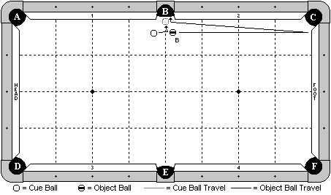

**Cue Ball**

In hand.

**Object Balls**

‘B’ ball in hand.

**Objective**

Shoot the cue ball into ‘B’ ball, causing it to bank off the foot cushion, optionally hit cushion 2, and then carom off the cue ball and go into pocket ‘B’.

**Special Notes**

None.

# Discipline 5 – Shot 5c – 10 points

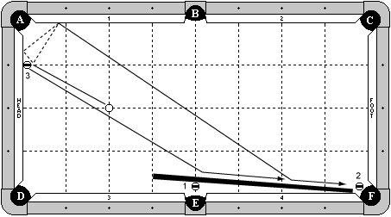

**Cue Ball**

On head spot.

**Object Balls**

3 ball frozen to head cushion, one diamond from pocket ‘A’.

1 ball hanging in pocket ‘E’ with edge even with the pocket cut or deeper.

2 ball hanging near pocket ‘F’.

A cue is placed as diagrammed. The end of the cue may not be past one diamond to the left of pocket ‘E’.

**Objective**

Shoot cue ball into 3 ball. 3 ball will bank into pocket ‘F’. Cue ball will optionally hit the head cushion, but will hit cushion 1, then the cue stick, making 1 ball in pocket ‘E’, and roll down the cue stick making 2 ball in pocket ‘F’. Then the 3 ball will go in to pocket ‘F’.

**Special Notes**

All balls must be made in numerical order.

Extra contact between cue ball and 3 ball is okay.

**DISCIPLINE**

**6**

**STROKE SHOTS**

# Discipline 6 – Shot 1a – 6 points

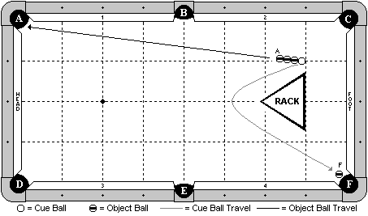

**Cue Ball**

In hand, but the back edge of the cue ball must be even with the back edge of the rack or closer to foot cushion.

**Object Balls**

Three balls are in line and frozen to each other and to the cue ball. ‘F’ ball is hanging near pocket ‘F’. The rack is placed in normal racking position.

**Objective**

Shoot the cue ball into the line of 3 balls. The first ball (‘A’) will go into pocket ‘A’. The cue ball will curve around the rack and make ‘F’ ball.

**Special Notes**

The other two balls in line do not need to be made. The cue ball may not contact the rack until after ‘F’ ball is made. Once the cue ball is struck and it separates from the line of balls, the cue ball may not be contacted by any other ball until ‘F’ ball is made. If the rack has a lip, it will be placed lip down.

# Discipline 6 – Shot 1b – 6 points

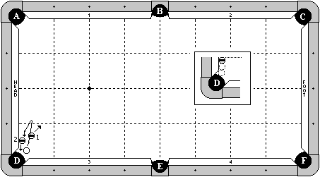

**Cue Ball**

In hand, but the right edge may not be past the pocket point on cushion 3.

**Object Balls**

2 ball is frozen to the head cushion, and is the third ball out from the pocket cut. See the close-up view for more information. The 1 ball is in hand, but may be no more than 1 chalk’s width from the 2 ball. Also, the back edge of the 1 ball may not be past the forward edge of the 2 ball (indicated in the close-up view by a dotted line).

**Objective**

Shoot the cue ball into the 1 ball. The cue ball will jump over and draw back, making the 2 ball in pocket ‘D’.

**Special Notes**

The cue ball may make multiple hits on the 2 ball and head cushion. The cue ball may not contact any other cushion until hitting the 2 ball on the way back. The 1 ball does not need to be made.

# Discipline 6 – Shot 1c – 6 points

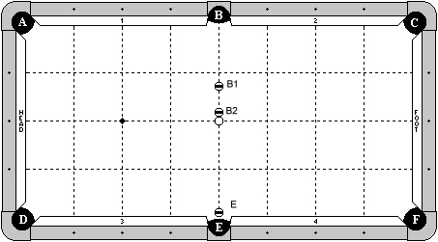

**Cue Ball**

On center spot.

**Object Balls**

All object balls on center line of table.

‘B2’ ball frozen to cue ball.

‘B1’ ball exactly two ball widths from ‘B2’ ball.

‘E’ ball hanging in pocket ‘E’, even with the rail line extension or deeper.

**Objective**

Shoot cue ball in to ‘B2’ ball. ‘B2’ ball will hit ‘B1’ ball in to pocket ‘B’. Cue ball will contact ‘B2’ ball a second time, hitting it in to pocket ‘B’. Cue ball will then draw back making ‘E’ ball.

**Special Notes**

‘E’ ball must be on center line. It is not adjustable left or right.

# Discipline 6 – Shot 2a – 7 points

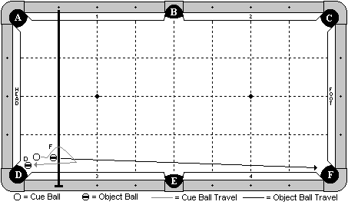

**Cue Ball**

In hand within 1x1 diamond zone near pocket ‘D’.

**Object Balls**

‘F’ ball in hand within 1x1 diamond zone near pocket ‘D’. ‘D’ ball hanging near pocket. Bridge is on the rail top along the 1st diamond. Players have the option of propping up the bridge with any object.

**Objective**

Shoot the cue ball into ‘F’ ball, making it in pocket ‘F’. The cue ball will jump over the bridge, and draw back under it, to make ‘D’ ball.

**Special Notes**

The bridge may be contacted without penalty. The cue ball may contact cushion 3 or the head cushion prior to making ‘D’ ball, but no other cushion.

# Discipline 6 – Shot 2b – 7 points

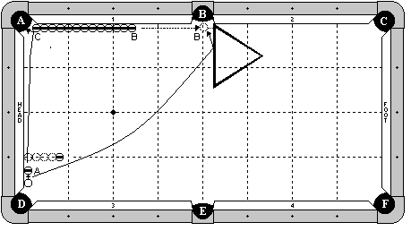

**Cue Ball**

Frozen to the head cushion, and the back edge is aligned with the pocket point.

**Object Balls**

‘A’ ball frozen to the head cushion and adjustable. 13 balls are in line, all frozen to cushion 1. The first ball (‘C’) may be inside the pocket jaws. A blocker ball is on the 1st diamond, exactly 4 ball’s width from the cushion. A rack is wedged into the side pocket, and the left edge is perpendicular to the cushion.

**Objective**

Shoot the cue ball into the ‘A’ ball, making it in pocket ‘A’. The ball will carom off ‘C’ ball, causing ‘B’ ball to travel up the rail, possibly hitting the rack and sitting in front of the pocket. The cue ball will curve around the blocker ball and make ‘B’ ball in pocket ‘B’, optionally hitting the rack on its way.

**Special Notes**

The blocker ball may not be contacted by any means until after ‘B’ ball has been made. The rack must be perpendicular. When ‘B’ ball hits the rack, it may not go in on its own. It must sit there and wait for the cue ball to knock it in.

# Discipline 6 – Shot 2c – 7 points

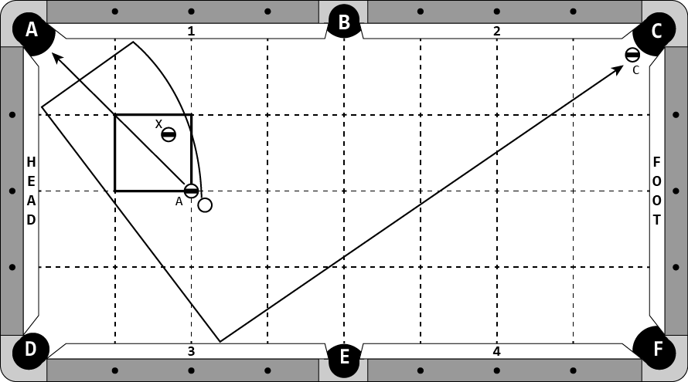

**Cue Ball**

In hand, but no more than 1 chalk width from ‘A’ ball.

**Object Balls**

‘A’ ball is on the head spot. ‘C’ ball is hanging in pocket ‘C’. ‘X’ ball is in hand within the indicated zone.

**Objective**

Shoot the cue ball into ‘A’ ball. ‘A’ ball will go in to pocket ‘A’. Cue ball will curve around ‘X’ ball, contact cushion 1, head cushion, and cushion 3, then make ‘C’ ball.

**Special Notes**

‘A’ ball and cue ball must travel on opposite sides of ‘X’ ball.

‘X’ ball may not be contacted by any means.

# Discipline 6 – Shot 3a – 8 points

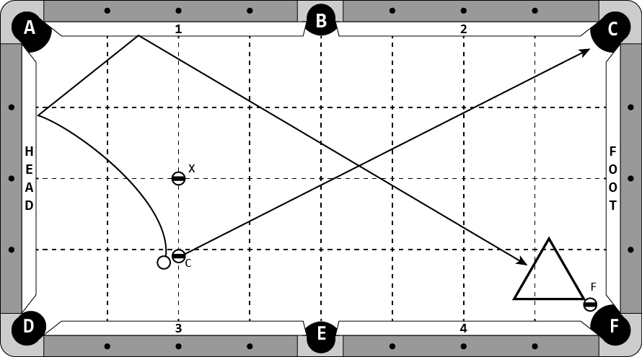

**Cue Ball**

In hand, exactly 2mm away from ‘C’ ball.

**Object Balls**

‘C’ ball in hand on the headstring, between ‘X’ ball and cushion 3. ‘X’ ball is on the head spot. ‘F’ ball is hanging in pocket ‘F’. A rack is in hand, frozen to ‘F’ ball.

**Objective**

Shoot cue ball using a fouette stroke, making ‘C’ ball in pocket ‘C’. Cue ball will contact head cushion and cushion 1, hitting the rack and pocketing ‘F’ ball.

**Special Notes**

Cue ball may contact cushion 4 or foot cushion and pocket ‘F’ ball with or without hitting the rack.

# Discipline 6 – Shot 3b – 8 points

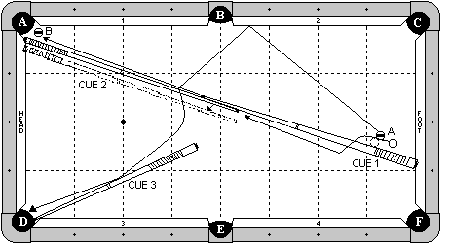

**Cue Ball**

In hand, but may not be more than 1 chalk’s width from ‘A’ ball.

**Object Balls**

‘A’ ball is approximately 1 ball’s width from the cue stick, but it is adjustable. ‘B’ ball is hanging near pocket ‘A’. Three cue sticks are on the table. Cue stick # 1 has the butt end against the foot cushion at the 1st diamond. Cue stick 2 has the butt end against the head cushion. Both cue stick 1 and 2 meet at the tip end and the sticks are both lined up so there is no gap between the sticks where they meet. Cue stick # 3 has the tip end wedged into pocket ‘D’ and it adjustable.

**Objective**

Shoot the cue ball into ‘A’ ball. ‘A’ ball will bank off cushion 2, hit and jump over the sticks (separating them), hit cue stick # 3 (optional), and go into pocket ‘D’. The cue ball will jump over cue stick # 1, follow between the gap that now exists between the two cue sticks, and make ‘B’ ball in pocket ‘A’.

**Special Notes**

The cue ball may hit cue stick # 1 when jumping over it. The cue ball must make ‘B’ ball. It may not be hit in by the cue stick. Players selecting this shot are required to supply the 3 cue sticks.

A shot clock with a time limit of 90 seconds will be placed on this challenge for the set up period.

# Discipline 6 – Shot 3c – 8 points

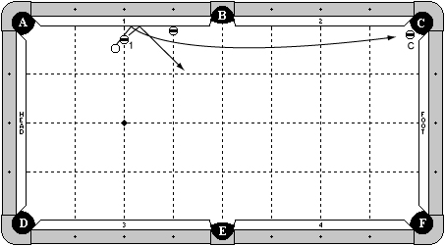

**Cue Ball**

In hand, less than one chalk width from 1 ball.

**Object Balls**

1 ball is 1 ball width from cushion one on second diamond line.

Blocker ball is frozen to cushion 1 at third diamond.

‘C’ ball is hanging in pocket ‘C’.

**Objective**

Shoot cue ball in to 1 ball. 1 ball will hit cushion 1 and bank out of the way. Cue ball will follow into cushion one, rebound out and around the blocker ball and continue up table to make ‘C’ ball in pocket ‘C’.

**Special Notes**

Cue ball and 1 ball may not re-contact each other after initial hit.

Cue ball must make ‘C’ ball.

# Discipline 6 – Shot 4a – 9 points

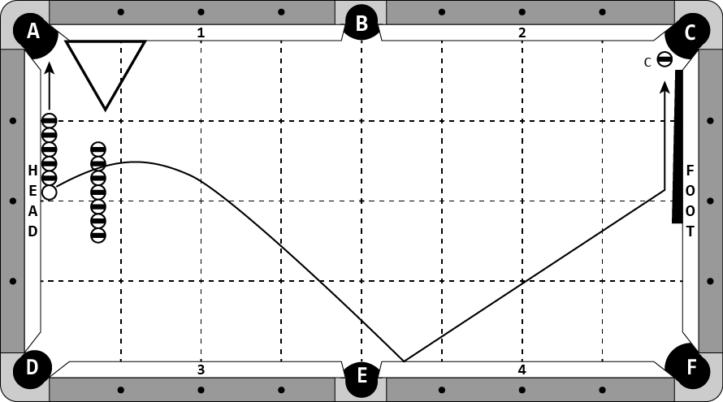

**Cue Ball**

Frozen to the line of object balls and to head cushion

**Object Balls**

5 object balls are in line frozen to the head cushion. The 1st ball is on the 1st diamond. A row of 7 object balls are placed two ball widths from the other line of balls. The middle ball is in line with the cue ball. A rack is frozen to cushion 1, as diagrammed. ‘C’ ball is hanging near pocket ‘C’. A cue butt is frozen to the foot cushion.

**Objective**

Shoot into the row of 5 balls. All 5 balls will go in pocket ‘A’. Cue ball will jump over row of blocker balls, contact cushion 3 or 4, and make the hanger, optionally with the help of the butt.

**Special Notes**

The row of blocker balls may not be contacted by any means until after ‘C’ ball is made.

The cue ball may not contact the rack until after ‘C’ ball is made.

# Discipline 6 – Shot 4b – 9 points

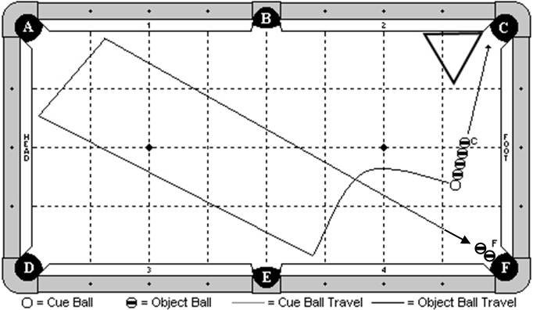

**Cue Ball**

In hand, but no more than 2 diamonds away from the foot cushion.

**Object Balls**

4 balls are frozen in line, and to the cue ball. ‘F’ ball combo is hanging near pocket ‘F’.

A rack is in hand, frozen to cushion 2.

**Objective**

Shoot the cue ball into the line of 4 balls. All four object balls will go into pocket C. The cue ball will draw back and around 3 cushions as diagrammed, and make ‘F’ ball.

**Special Notes**

The cue ball may hit cushion 3 or 4 as the first cushion.

# Discipline 6 – Shot 4c – 9 points

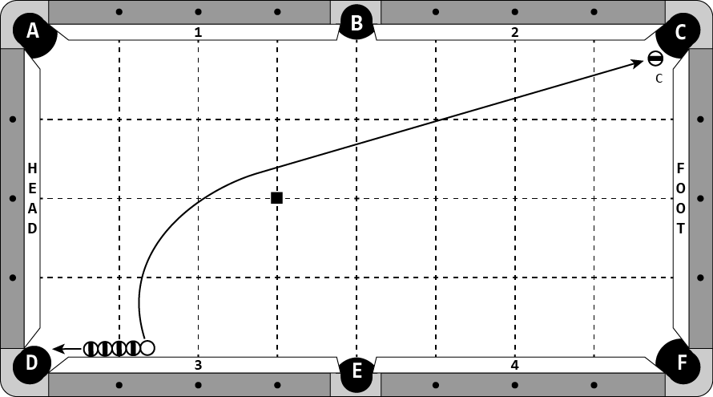

**Cue Ball**

Frozen to the line of balls and to cushion 3.

**Object Balls**

Four object balls are in a line, frozen to cushion 3. The 3rd object ball is on the 1st diamond line. ‘C’ ball is hanging in pocket ‘C’. A chalk is at the diamond intersection as diagrammed.

**Objective**

Shoot into the row of balls. The head ball will go into pocket ‘D’. The cue ball will curve around the chalk and pocket ‘C’ ball.

**Special Notes**

Cue ball may not contact chalk until after contacting ‘C’ ball.

# Discipline 6 – Shot 5a – 10 points

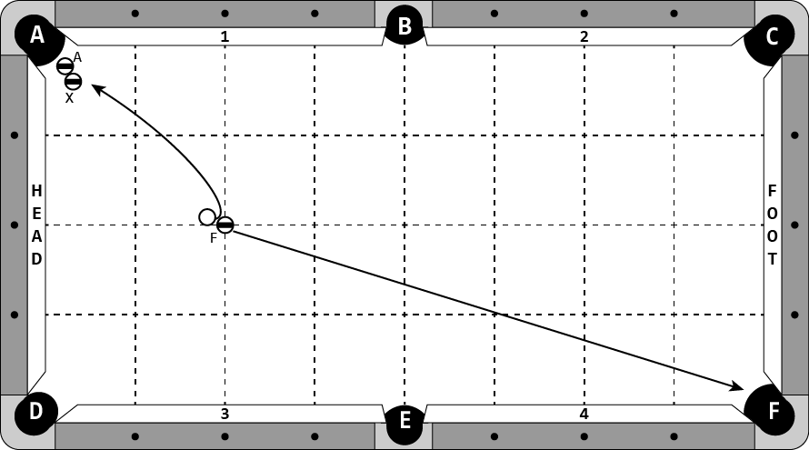

**Cue Ball**

In hand, exactly 2mm from ‘F’ ball.

**Object Balls**

‘F’ ball is on head spot. ‘A’ ball is hanging in pocket ‘A’. ‘X’ ball is in hand frozen to ‘A’ ball.

**Objective**

Shoot the cue ball using a fouette stroke pocketing the ‘F’ ball. Cue ball will draw back pocketing ‘A’ ball.

**Special Notes**

Cue ball may contact cushion 1 or head cushion. Cue ball is not required to hit ‘X’ ball.

# Discipline 6 – Shot 5b – 10 points

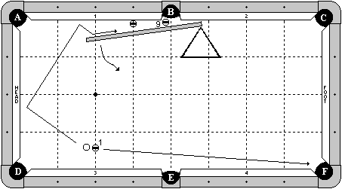

**Cue Ball**

In hand, but must be exactly 2mm from the 1 ball.

**Object Balls**

1 ball on the 2nd diamond, and no more than 3 ball’s width from the cushion. 9 ball is hanging near pocket ‘B’. A blocker ball is frozen to cushion 1 and on the 3rd diamond. A short jump cue is in position as diagrammed. It is adjustable, but it may be no more than 1 chalk’s width from the blocker ball. A rack is in position to keep the jump cue from moving too much.

**Objective**

Shoot the cue ball into the 1 ball, making it in pocket ‘F’. The cue ball will draw back into the head cushion, and then go into the gap between the cue stick and the cushion. The cue ball will swing the jump cue out so the cue ball can go around the blocking ball, and make the 9 ball.

**Special Notes**

It is okay for the cue ball to hit the blocker ball, provided that the cue ball (not the blocker or the stick) makes the 9 ball. Players selecting this shot will be required to provide the jump cue.

# Discipline 6 – Shot 5c – 10 points

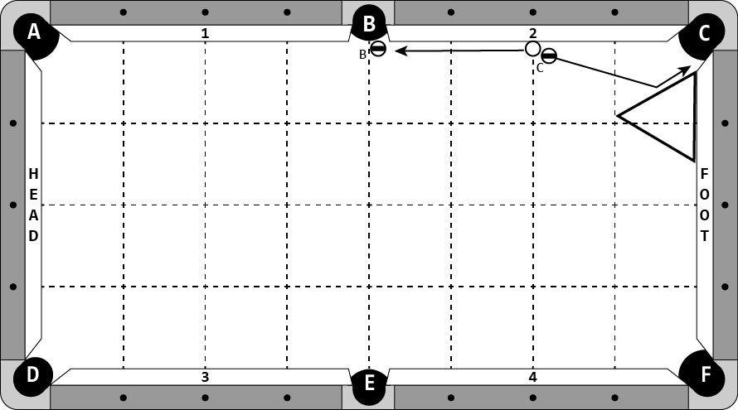

**Cue Ball**

Frozen to cushion 2 at the 2nd diamond.

**Object Balls**

‘C’ ball is exactly 2mm from cue ball and may not be frozen to cushion 2. ‘B’ ball is hanging in pocket ‘B’. A rack is frozen to the foot cushion as diagrammed.

**Objective**

Shoot cue ball into ‘C’ ball. ‘C’ ball will hit the rack and go into pocket ‘C’. Cue ball will draw up the rail and pocket ‘B’ ball.

**Special Notes**

This is not a masse shot, players must use a fouette stroke. Cue ball may only contact cushion 2.

**DISCIPLINE**

**7**

**JUMP SHOTS**

# Discipline 7 – Shot 1a – 6 points

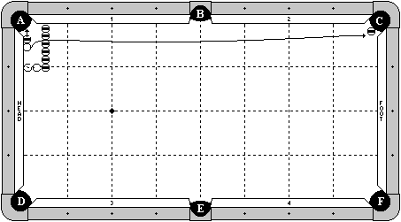

**Cue Ball**

In hand between head cushion and blocker balls.

**Object Balls**

‘A’ ball is in hand, but frozen to the cue ball.

‘C’ ball is hanging in pocket ‘C’.

A row of 6 blocker balls is exactly two ball widths from head cushion.

**Objective**

Jump cue ball over the blocker balls. ‘A’ ball will go in to pocket ‘A’. Cue ball will hit ‘C’ ball in to pocket ‘C’.

**Special Notes**

Blocker balls may not be contacted by any means until after object balls are made.

# Discipline 7 – Shot 1b – 6 points

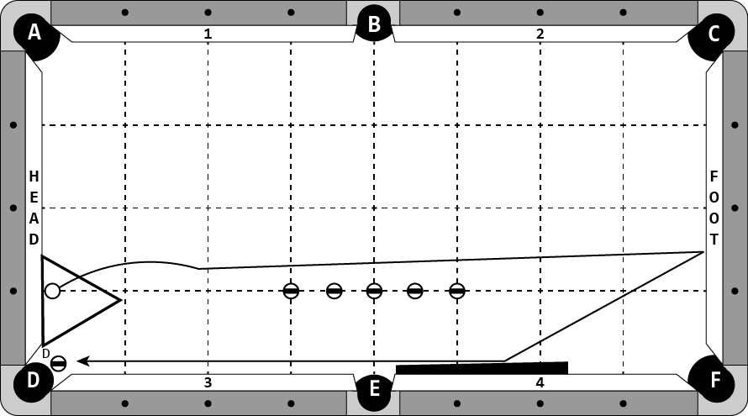

**Cue Ball**

In hand within the rack.

**Object Balls**

‘D’ ball hanging in pocket ‘D’.

A row of 5 object balls are evenly spaced on the 1st diamond line from cushions 3 and 4 and between the 3rd diamonds, as diagrammed.

A cue butt is frozen against cushion 4.

A rack is frozen to the head cushion. The point of the rack is even with the point of the corner pocket or deeper.

**Objective**

Jump the cue ball out of the rack, hitting foot cushion, the cue stick or cushion 3, and making ‘D’ ball, optionally hitting the rack.

**Special Notes**

The cue ball may not contact the rack on the initial jump.

The blocker balls may not be contacted by any means until after ‘D’ ball is made.

The player may not contact the rack with their cue stick.

The cue ball must travel on opposite sides of the blocker balls before and after hitting the foot cushion, as diagrammed.

# Discipline 7 – Shot 1c – 6 points

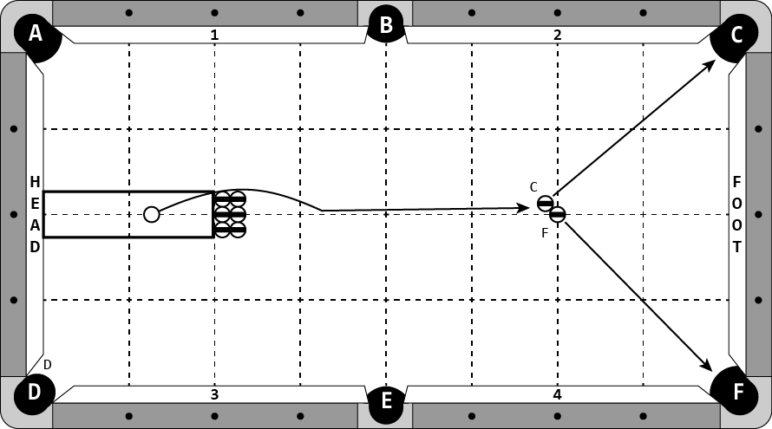

**Cue Ball**

In hand between the head cushion and blocker balls, but within the edges of the blocker balls.

**Object Balls**

‘F’ ball on foot spot.

‘C’ ball in hand, frozen to ‘F’ ball.

A 3 x 2 array of blocker balls are arranged as diagrammed. The middle balls are on the centerline of the table and the back row of balls have their back edge even with the headstring.

**Objective**

Shoot the cue ball, one-handed jacked up, over the blocker balls into ‘C’ and ‘F’ balls. ‘C’ and ‘F’ balls will go into designated pockets.

**Special Notes**

Blocker balls may not be contacted by any means until after ‘C’ and ‘F’ balls are made.

# Discipline 7 – Shot 2a – 7 points

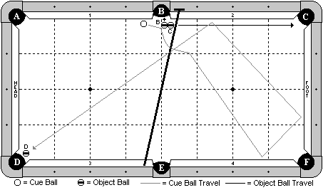

**Cue Ball**

In hand.

**Object Balls**

‘B’ and ‘C’ balls frozen near pocket ‘B’ and adjustable. ‘D’ ball hanging near pocket ‘D’. The bridge is on the rail tops, with the head of the bridge near pocket ‘B’. The player has the option to prop up the butt end of the bridge with a chalk cube.

**Objective**

Shoot the cue ball into ‘B’ ball. ‘B’ and ‘C’ balls will go as pocket letter designates. The cue ball will jump over the bridge, travel three cushions as diagrammed, and make ‘D’ ball.

**Special Notes**

The cue ball may hit the bridge.

# Discipline 7 – Shot 2b – 7 points

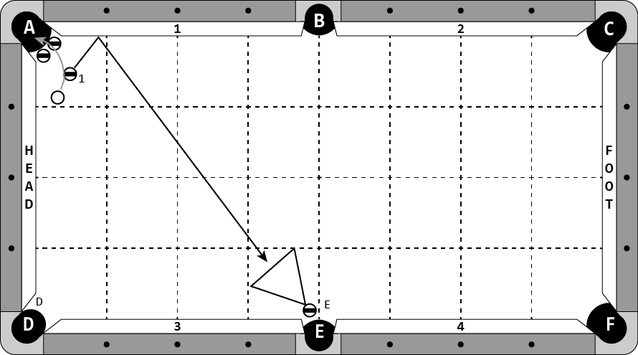

**Cue Ball**

In hand.

**Object Balls**

‘1’ ball is in hand.

‘E’ ball is hanging in pocket ‘E’.

A rack is frozen to ‘E’ ball.

Two blocker balls are in pocket ‘A’, even with the pocket cut. If two balls will not fit in the jaws of the pocket, the two balls will be frozen to each other and to the head cushion and cushion 1.

**Objective**

Jump the cue ball into 1 ball. 1 ball will bank, hitting the rack and pocketing ‘E’ ball. Cue ball will jump over the blocker balls into pocket ‘A’.

**Special Notes**

The blocker balls may not be contacted by any means until after ‘E’ ball goes in.

# Discipline 7 – Shot 2c – 7 points

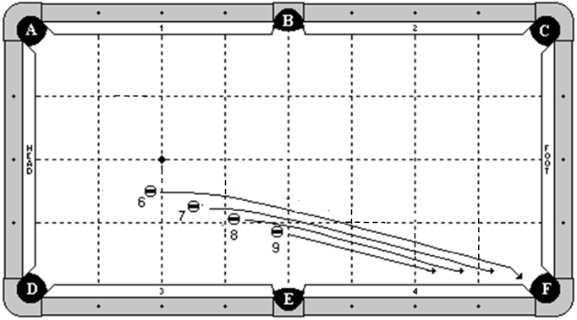

**Cue Ball**

None.

**Object Balls**

The 6 through 9 balls are lined straight towards pocket ‘F’. They are in hand to the left of the B-E center line, but they must be all straight in line with each other and towards pocket ‘F’.

**Objective**

Jump the 6 ball, then the 7 ball, and finally the 8 ball. Each will be jumped into pocket ‘F’. Lastly, shoot the 9 ball straight into pocket ‘F’.

**Special Notes**

When jumping a ball, none of the other balls may be disturbed by any means.

# Discipline 7 – Shot 3a – 8 points

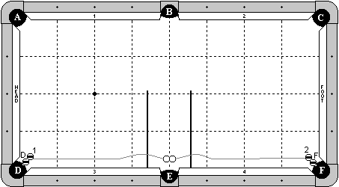

**Cue Ball**

Two cue balls are frozen together near pocket ‘E’, splitting the centerline of the table. Object balls may be substituted.

**Object Balls**

‘D’ and ‘F’ balls are hanging near their respective pockets. ‘1’ ball is frozen to ‘D’ ball. ‘2’ ball is frozen to ‘F’ ball.

Two cue butts are placed perpendicular to cushions 3 and 4, frozen to cushions 3 and 4, and at least 2 ball widths from cue balls.

**Objective**

Shoot down between cue balls. Left cue ball will jump over left butt and make ‘D’ ball. Right cue ball will jump over right butt and make ‘F’ ball.

**Special Notes**

The left cue ball may only contact cushion 3 or head cushion until after ‘1’ or ‘D’ ball has been contacted.

The right cue ball may only contact cushion 4 or foot cushion until after ‘2’ or ‘F’ ball has been contacted.

The cue butts may not be contacted by any means until after ‘D’ and ‘F’ balls have been made.

A masse cloth will be required to be used on this shot, placed underneath and/or between the two cue balls.

# Discipline 7 – Shot 3b – 8 points

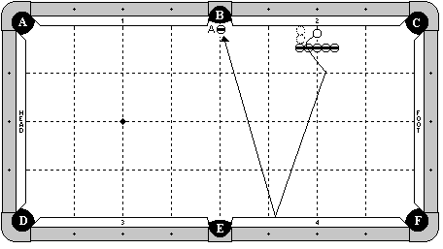

**Cue Ball**

In hand between the blocker balls and the cushion. The cue ball may not be adjusted left or right so that the edge passes the 2nd diamond line.

**Object Balls**

A row of 5 object balls are exactly 2 ball’s width off the cushion. The center ball is on the 2nd diamond line. ‘A’ ball is hanging near pocket ‘B’.

**Objective**

Jump the cue ball over the blocker balls, bank one rail, and make ‘A’ ball.

**Special Notes**

The blocker balls may not be touched by any means until after ‘A’ ball is made.

# Discipline 7 – Shot 3c – 8 points

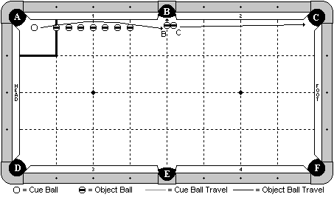

**Cue Ball**

In hand within the indicated zone, but must be directly in line with the other balls.

**Object Balls**

‘B’ and ‘C’ balls are as diagrammed near pocket ‘B’. They must be directly in line with the other balls. 7 blocker balls are in a straight line. The end balls are on the 1st and 3rd diamond lines, and the middle ball is on the 2nd diamond line. The blockers may not be more than 1 chalk’s width off the cushion. All balls, including the cue ball and the balls near pocket ‘B’ must be in a straight line.

**Objective**

Jump the cue ball over the line of blockers, and make ‘B’ ball in pocket ‘B’ and ‘C’ ball in pocket ‘C’.

**Special Notes**

The blocker balls may not be contacted by any means until after the cue ball has contacted ‘B’ ball.

# Discipline 7 – Shot 4a – 9 points

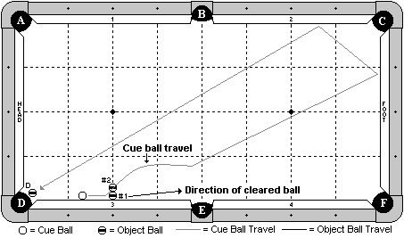

**Cue Ball**

In hand, frozen to cushion 3.

**Object Balls**

1 ball and 2 ball are frozen in line on the 2nd diamond, with the 1 ball frozen to the cushion. ‘D’ ball is hanging.

**Objective**

Shoot the cue ball into the 1 ball. The cue ball will jump over the 2 ball, travel 2 cushions as diagrammed, and make ‘D’ ball.

**Special Notes**

The 2 ball may not move by any means until after ‘D’ ball is made.

# Discipline 7 – Shot 4b – 9 points

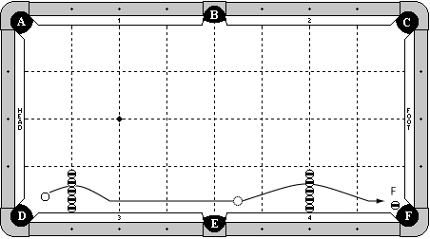

**Cue Ball**

In hand between the row of blocking balls and the head cushion.

**Object Balls**

‘F’ ball is hanging in pocket ‘F’.

A row of 5 blocking balls is on the 1st diamond, frozen to cushion 3.

A row of 5 blocking balls is on the 2nd diamond, frozen to cushion 4.

**Objective**

Jump the cue ball over the first row of blocking balls. While it is rolling, jump the cue ball again over the second row of blocking balls, making ‘F’ ball.

**Special Notes**

Cue ball must be moving when struck the second time. Table judge’s decision is final.

Cue ball may not fly off the table.

Blocking balls may not be contacted by any means until after ‘F’ ball is made.

Cue ball must clearly jump over the 2nd row of blocker balls. Table judge’s decision is final.

# Discipline 7 – Shot 4c – 9 points

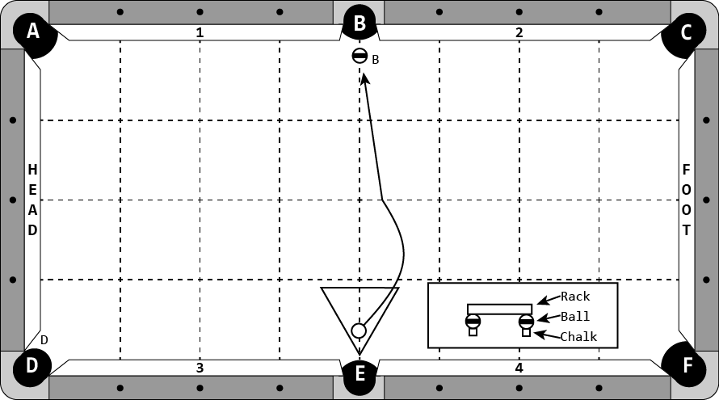

**Cue Ball**

In hand, within the footprint of the rack.

**Object Balls**

‘B’ ball hanging in pocket ‘B’.

A rack is propped up by a chalk cube and object ball under each of its vertices. The rack is centered on the centerline of the table. The point closest to pocket ‘E’ must be within one ball width of the pocket cut.

**Objective**

Jump the cue ball over the rack and make ‘B’ ball.

**Special Notes**

The rack, chalks, and object balls may not be contacted by any means until after ‘B’ ball is made.

# Discipline 7 – Shot 5a – 10 points

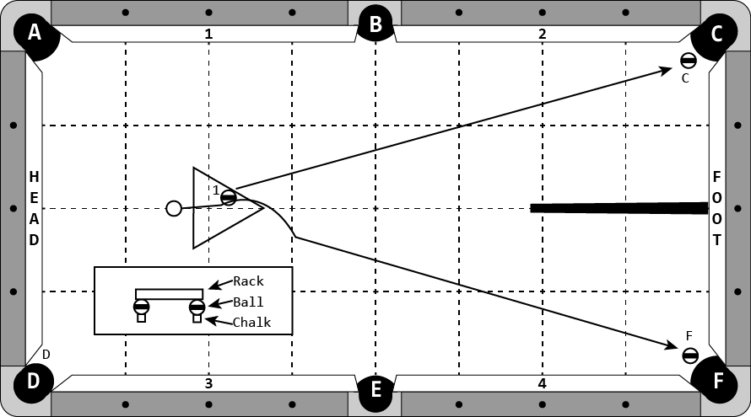

**Cue Ball**

In hand

**Object Balls**

‘C’ and ‘F’ balls hanging in their respective pockets.

‘1’ ball in hand within the footprint of the rack.

A rack is propped up by a chalk cube and object ball under each of its vertices. The rack is centered on the long centerline of the table and on the left side of the table.

A cue butt is frozen to the foot cushion along the centerline of the table.

**Objective**

Shoot the cue ball into ‘1’ ball. ‘1’ ball will make ‘C’ ball. Cue ball will jump over the rack and make ‘F’ ball.

**Special Notes**

The chalk, object balls, and rack may not be contacted by any means until after ‘C’ and ‘F’ balls are made.

The cue butt is only a barrier to prevent ‘1’ ball from caroming off ‘C’ ball and interfering with the cue ball. The cue butt may be contacted by the ‘1’ ball after making ‘C’ ball.

# Discipline 7 – Shot 5b – 10 points

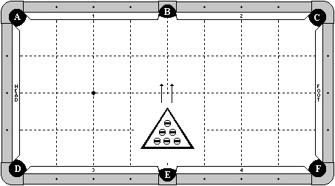

**Cue Ball**

None.

**Object Balls**

6 object balls are in hand within a rack. A rack is placed centered on the B-E center line. The point of the rack may not pass the long center line of the table.

**Objective**

Using a 1-handed jacked up stroke, jump all object balls out of the rack, one at a time, into pocket ‘B’.

**Special Notes**

The rack may not be contacted by any means. When jumping a ball, no other ball may be disturbed.

# Discipline 7 – Shot 5c – 10 points

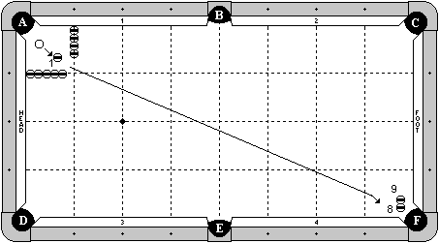

**Cue Ball**

In hand within the 1x1 diamond zone.

**Object Balls**

1 ball in hand within the 1x1 diamond zone. 8 ball is a special stacking ball near pocket ‘F’. 9 ball is balanced on top of it. 4 balls are frozen in line on the 1st diamond, with the first ball frozen to cushion 1. 5 balls are frozen in line on the 1st diamond, with the first ball frozen to the head cushion.

**Objective**

Shoot the cue ball into the 1 ball, causing it to roll towards the stacked balls. Re-hit the cue ball, jumping it over the 1 ball. The cue ball will make the 8 ball (bottom ball), and get of the way. The 1 ball will then make the 9 ball, which fell in place.

**Special Notes**

The cue ball, 1 ball, and stacked balls must all be in line. The blocker balls may not be contacted by any means until after the 8 ball is made. The 9 ball must be made by the 1 ball. It may not fall on its own or be made by the cue ball. After the initial contact between the cue ball and 1 ball, the 1 ball may not contact any other ball until it hits the 9 ball.

On a 7-ft table, only 3 blocker balls will be used on each diamond line.

**DISCIPLINE**

**8**

**MASSE SHOTS**

# Discipline 8 – Shot 1a – 6 points

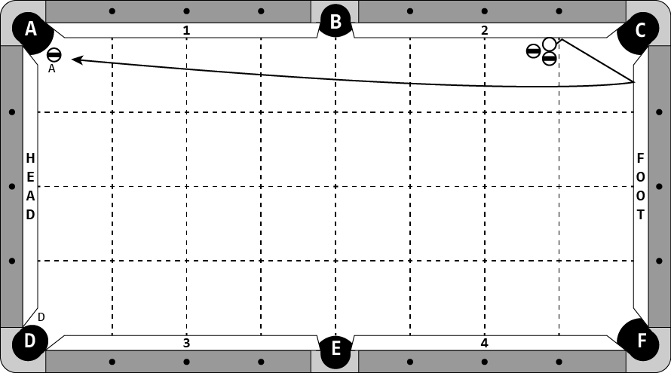

**Cue Ball**

Frozen to cushion 3, adjustable between the 1st and 2nd diamonds. The cue ball may be on either of the diamond lines.

**Object Balls**

One object ball is frozen in line with the cue ball. Another blocking ball is placed within one chalk width of the cue ball and within one chalk width of cushion 3, as diagrammed.

‘F’ ball is hanging in pocket ‘F’.

**Objective**

Shoot cue ball into cushion 3. It will escape from the blocker balls, contact head cushion, and make ‘F’ ball.

**Special Notes**

Blocker balls may not move by any means until after ‘F’ ball is made.

# Discipline 8 – Shot 1b – 6 points

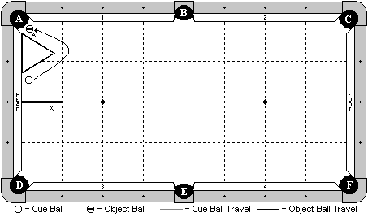

**Cue Ball**

In hand within one ball width of head cushion and between rack and line ‘X’.

**Object Balls**

‘A’ ball is hanging in pocket ‘A’.

A rack is in hand with one edge frozen to head cushion.

**Objective**

Masse cue ball around the rack to make ‘A’ ball.

**Special Notes**

Cue ball may contact rack at any time.

Cue ball may contact cushions 1 and 2 only.

Cue ball may not come back by hitting point of pocket ‘B’.

# Discipline 8 – Shot 1c – 6 points

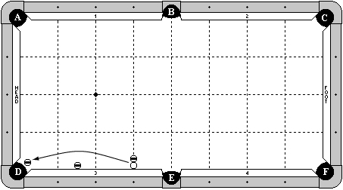

**Cue Ball**

Frozen to cushion 3 – one diamond from pocket ‘E’.

**Object Balls**

An object ball is hanging in pocket ‘D’.

One blocker ball is frozen to cue ball, directly in line along the diamond line. One blocker ball is frozen to cushion 3 at 1½-diamond segments from pocket ‘D’.

**Objective**

Masse the cue ball such that it escapes from between the blocking ball and rail and curves around the other blocking ball to make the object ball hanging in pocket ‘D’.

**Special Notes**

The blocking balls may not move by any means until the shot is complete.

# Discipline 8 – Shot 2a – 7 points

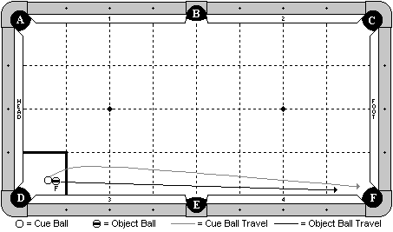

**Cue Ball**

In hand within the indicated zone.

**Object Balls**

‘F’ ball in hand within the indicated zone, frozen to the cue ball.

**Objective**

Shoot the cue ball, making ‘F’ ball in pocket ‘F’. The cue ball will move out to the left, speed up and pass ‘F’ ball, and go into pocket ‘F’ first.

**Special Notes**

Multiple contact between the two balls are allowed, provided that the cue ball goes into pocket ‘F’ first. Decision by the table judge is final.

# Discipline 8 – Shot 2b – 7 points

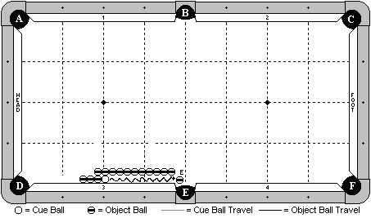

**Cue Ball**

Frozen to cushion 3 and to two other object balls next to it as diagrammed.

**Object Balls**

Three object balls are to the left of the cue ball, all frozen in line and to the cushion. 11 object balls are frozen in line exactly 1 ball’s width from cushion 3. The 11th ball is frozen to the object ball that is next to the cue ball. The 1st object ball in line may start anywhere to the left of the B-E center line. ‘E’ ball is hanging near pocket ‘E’ and is adjustable.

**Objective**

Masse the cue ball, causing the three balls to the left of the cue ball to move. The cue ball will masse back and finally make ‘E’ ball.

**Special Notes**

The cue ball must make ‘E’ ball, not another object ball. There is no requirement on how many balls must move, but players must setup the shot with the line of balls exactly 1 ball’s width off the cushion, and they must execute the shot with a full (or close to full) masse stroke.

# Discipline 8 – Shot 2c – 7 points

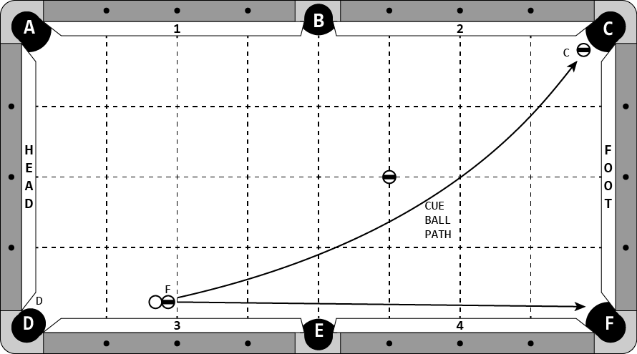

**Cue Ball**

In hand, behind head string.

**Object Balls**

‘F’ ball is frozen to cue ball, in hand behind head string.

‘C’ ball is hanging in pocket ‘C’.

A blocker ball is on the diamond intersection, as diagrammed.

**Objective**

Make ‘F’ ball in pocket ‘F’. Cue ball will follow the indicated path and make ‘C’ ball.

**Special Notes**

The blocker ball may not be contacted by any means until shot is complete.

# Discipline 8 – Shot 3a – 8 points

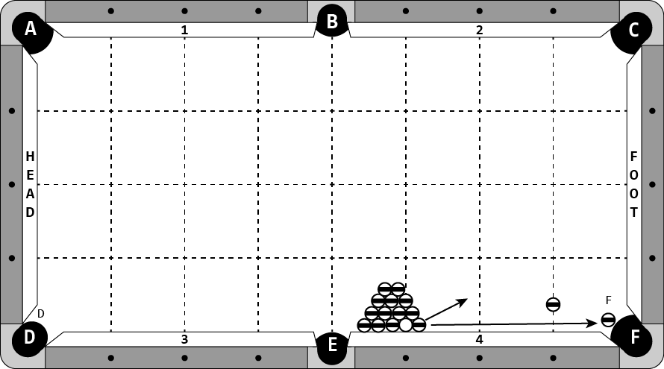

**Cue Ball**

Frozen to cushion 4 at the 3rd diamond.

**Object Balls**

13 object balls are placed in a standard rack formation (with the head ball missing) around the cue ball as diagrammed. A blocker ball is on the 1st diamond and exactly 1 ball + 1 chalk’s width from the cushion. ‘F’ ball is hanging.

**Objective**

Masse the cue ball, causing the balls in the rack to scatter. The end ball will get out of the way, and the cue ball will masse along the cushion, between the blocker ball and the cushion, and make ‘F’ ball.

**Special Notes**

Players must perform a full masse. Masse stroke must be performed in one fluid motion.

The blocker ball may not be hit by any means until after ‘F’ ball is made.

The ‘F’ ball must be made by the cue ball.

The object ball to the right of cue ball must not go through the gap between the blocker ball and the cushion.

# Discipline 8 – Shot 3b – 8 points

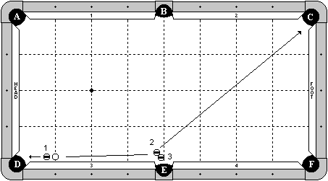

**Cue Ball**

On the first diamond line, no more than 1 chalk’s width from the cushion.

**Object Balls**

1 ball is in hand, but must be at least 1 chalk’s width from the cue ball. The 2 and 3 balls are in hand near pocket ‘E’.

**Objective**

Masse the cue ball, making the 1 ball in pocket ‘D’. The cue ball will masse back into the 2 ball, making it in pocket ‘C’ and making the 3 ball in pocket ‘E’.

**Special Notes**

Players must use a full masse stroke for this shot. They may not use a draw stoke.

# Discipline 8 – Shot 3c – 8 points

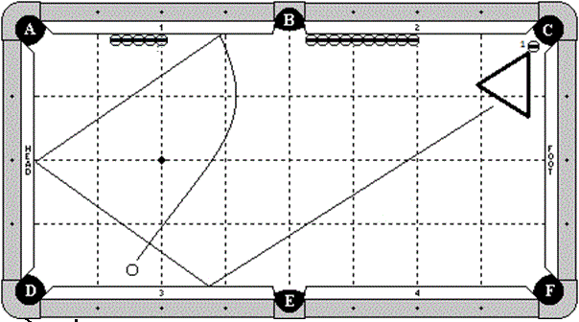

**Cue Ball**

One ball width off the 1-1/2 diamond mark on cushion 3.

**Object Balls**

Five blocker balls are frozen to cushion 1, starting at the 2nd diamond. Nine blocker balls are frozen to cushion 2, starting at the point of the side pocket. ‘1’ ball is hanging near pocket ‘C’. A rack is frozen to ‘1’ ball.

**Objective**

Masse the cue ball to hit cushion 1, head cushion, cushion 3, and then the rack, making ‘1’ ball.

**Special Notes**

Blocker balls may not be contacted by any means until after ‘1’ ball is made.

The cue ball may contact an extra rail near the rack, but the rack must make the ‘1’ ball. The cue ball may not squeeze in between the rack and the rail to make ‘1’ ball directly.

If a break cloth is used, players may pick it up during the course of the shot as long as the player does not interfere with the cue ball in any way.

# Discipline 8 – Shot 4a – 9 points

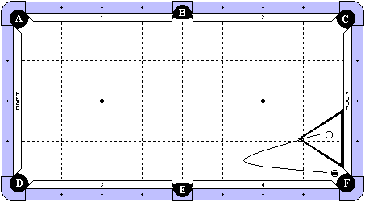

**Cue Ball**

In hand within the rack.

**Object Balls**

An object ball is hanging near pocket ‘F’. A rack is frozen to the foot cushion as diagrammed.

**Objective**

Hit the cue ball with a jump masse stroke. It will jump out of the rack, turn around and come back to make the object ball in pocket ‘F’.

**Special Notes**

The rack may not be touched when the cue ball is jumping out of it, but it may be contacted when the cue ball comes back to make the object ball. The cue ball’s trailing edge must completely pass the 2nd diamond line. Decision by the referee is final. The cue ball may contact cushion 3 or 4, but none other until ‘F’ ball is made. The cue ball may not come back because it hit the far pocket point of pocket ‘E’. Decision by the referee is final.

# Discipline 8 – Shot 4b – 9 points

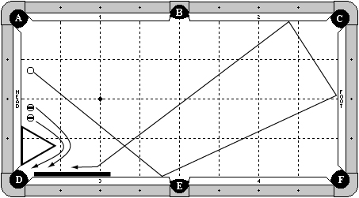

**Cue Ball**

In hand, but no more than 1 ball width from head cushion.

**Object Balls**

Two object balls are in hand, but no more than 1 ball width from head cushion.

A rack is in hand, frozen to the head cushion.

A cue butt is frozen to cushion 3.

**Objective**

Shoot the cue ball 3 rails as diagrammed, towards pocket ‘D’. While cue ball is rolling, masse the two object balls to go around the rack and in to pocket ‘D’. Cue ball will go in to pocket ‘D’ last.

**Special Notes**

Cue ball may contact cushion 3 or 4 as the first cushion.

Object balls may hit the rack at any time.

All balls may hit the cue butt.

Multiple contacts between the balls are allowed.

The order which the two object balls go in does not matter.

The cue ball must go in last.

Decision by table judge is final.

# Discipline 8 – Shot 4c – 9 points

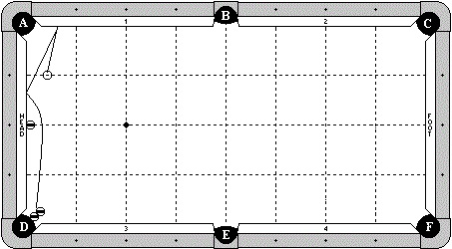

**Cue Ball**

In hand along the 1st diamond line.

**Object Balls**

A blocker ball is frozen to the head cushion at the 2nd diamond.

Two balls form a combination near pocket ‘D’.

**Objective**

Shoot the cue ball so it follows the indicated path, hitting cushion 1 and head cushion before making the combination.

**Special Notes**

The blocker ball may not be contacted by any means until combination is made.

# Discipline 8 – Shot 5a – 10 points

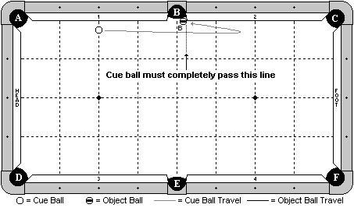

**Cue Ball**

Base of the cue ball is on the 2nd diamond line or to the left of it (towards the head cushion). It may not be more than 1 ball’s width from cushion 1.

**Object Balls**

‘B’ ball is placed frozen to the pocket point, and with the edge aligned with the pocket cut. This ball must be placed exactly as described. Players are not free to adjust this ball.

**Objective**

Masse the cue ball past the object ball. It will then come back and make ‘B’ ball in pocket ‘B’.

**Special Notes**

The trailing edge of the cue ball must completely pass the forward edge of the object ball (as indicated by the line drawn). Table judge will make the final call. The cue ball may contact cushion 1 or 2, but no other, until after ‘B’ ball is made.

# Discipline 8 – Shot 5b – 10 points

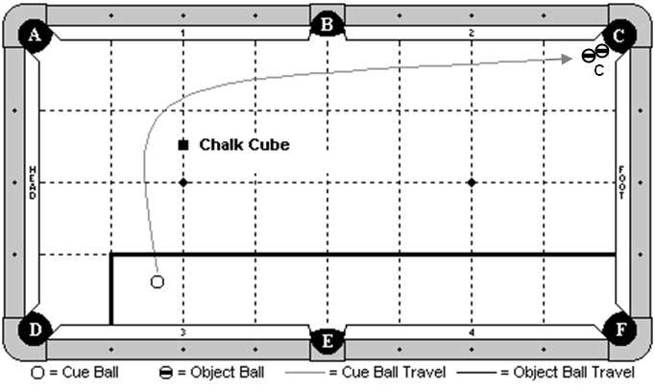

**Cue Ball**

In hand within the indicated zone.

**Object Balls**

‘C’ ball combo is at pocket C. A piece of chalk is placed square to the table along the head string, exactly 1 ½ diamonds from cushion 1.

**Objective**

Masse the cue ball around the chalk, along the indicated path, and make ‘C’ ball combo.

**Special Notes**

The chalk may not be contacted by any means until after ‘C’ ball is made. The cue ball may not contact the head cushion until after ‘C’ ball is made.

# Discipline 8 – Shot 5c – 10 points

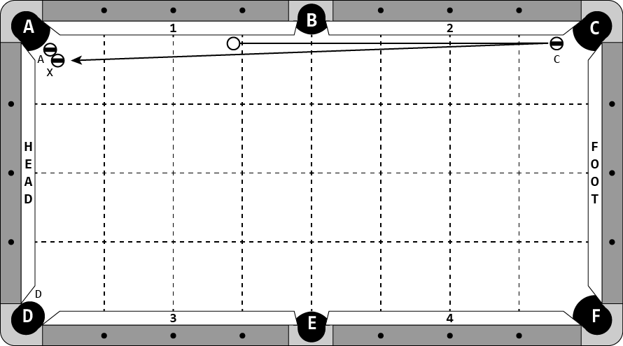

**Cue Ball**

In hand, behind the 3rd diamond line and not more than 1 ball width from cushion 1.

**Object Balls**

‘C’ ball is no more than 1 chalk width from cushion 2 with its edge even with point of pocket ‘C’.

‘A’ ball combination is hanging in pocket ‘A’.

**Objective**

Masse the cue ball to pocket the ‘C’ ball and masse back up the rail to make ‘A’ ball combination.

**Special Notes**

Cue ball may only contact cushions 1 and 2 before ‘A’ ball is made.

A masse stroke must be used.

If a masse cloth is used, player may pick it up during the shot. If the player interferes with the cue ball during this process, it will be a foul and the attempt is missed. If the player does not pick up the masse cloth and the cloth interferes with the shot, whatever the result is will stand.